Help for you and baby
The Help for you and baby website helps people to understand the checks and tests to expect during pregnancy, labour and after the baby is born. This toolkit will help to promote the website and access the advice. This toolkit has also been updated to encourage women who are pregnant to get the flu vaccination.

1. Bulletin copy
The Help for you and Baby website includes information on the tests and checks to expert during pregnancy, labour and after the baby is born and includes videos in different languages talking through the tests and checks. Help promote the website by using this toolkit and help parents navigate this chapter.
You can visit the website at Helpforyouandbaby.org
2. Social media content and graphic
Text | Image | ALT text
Do you have questions about tests during pregnancy?  Visit helpforyouandbaby.org to find advice on tests and checks during pregnancy, labour and after your baby is born. | 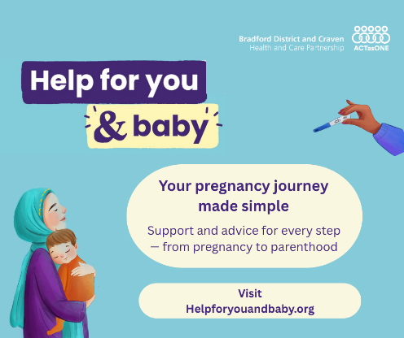  Download here | A graphic for Help for you and baby. Text that reads Help for you and baby. Your pregnancy journey made simple. Support and advice for every step – from pregnancy to parenthood. Visit Helpforyouandbaby.org
When pregnant, you are eligible for the flue vaccine to protect yourself and baby. You can get the flu vaccine at any stage of pregnancy if you’re pregnant in the winter.  Contact your GP practice or pharmacy to arrange a flu appointment from the first few weeks up to your expected due date.  Read more about what to expect during pregnancy here: | 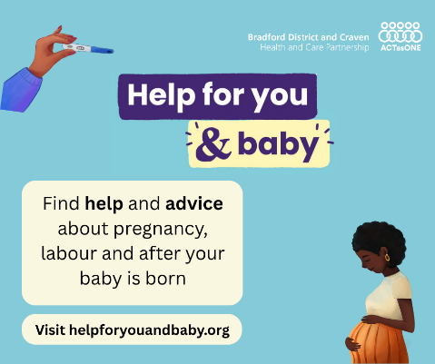  Download here | A graphic for Help for you and baby. Text that reads Find help and advice about pregnancy, labour and after your baby is born. Visit helpforyouandbaby.org
Did you know you can have the flu vaccine at any stage of pregnancy?  Contact your GP practice or pharmacy to arrange an appointment to protect you and baby  Read more here: helpforyouandbaby.org | Download here | A graphic for Help for you and baby. Text that reads Help for you and baby. Your pregnancy journey made simple. Support and advice for every step – from pregnancy to parenthood. Visit Helpforyouandbaby.org
Feeling overwhelmed about checks and tests during pregnancy?  Visit helpforyouandbaby.org to find out what to expect. | Download here | A graphic for Help for you and baby. Text that reads Find help and advice about pregnancy, labour and after your baby is born. Visit helpforyouandbaby.org
Unsure about what to expect during labour. The Help for you and baby website helps to explain what you could expect.  Visit helpforyouandbaby.org for more information | Download here | A graphic for Help for you and baby. Text that reads Help for you and baby. Your pregnancy journey made simple. Support and advice for every step – from pregnancy to parenthood. Visit Helpforyouandbaby.org

