Core20plus5 Bradford District and Craven - Programme Evaluation plan

The Reducing inequalities alliance are responsible alongside the Healthy community’s team in Bradford Health and Care partnership for the delivery of the Core20plus5 programme. The programme is being delivered from April 2023-March 2026. It is vital that we understand the impact, effectiveness, and efficiency of the programme as this will be crucial for informed decision making and continuous improvement of the programme. This evaluation plan serves as a systematic and structured approach to assess the strengths, weakness, and overall success of the programme. By examining the three main components of the Core20plus5 programme and the outcomes and processes we aim to derive valuable insights that can guide future actions, resource allocation and strategic planning to reduce health inequalities in Bradford district and Craven.

Introduction

Background

Core20plus5 National programme:
Core20PLUS5 is a national NHS England approach to inform action to reduce healthcare inequalities at both national and system level. The approach defines a target population – the ‘Core20PLUS’ – and identifies ‘5’ focus clinical areas requiring accelerated improvement.
Core20 - The most deprived 20% of the national population as identified by the national Index of Multiple Deprivation (IMD). The IMD has seven domains with indicators accounting for a wide range of social determinants of health.
PLUS - PLUS population groups should be identified at a local level. Populations we would expect to see identified are ethnic minority communities; people with a learning disability and autistic people; people with multiple long-term health conditions; other groups that share protected characteristics as defined by the Equality Act 2010; groups experiencing social exclusion, known as inclusion health groups coastal communities (where there may be small areas of high deprivation hidden amongst relative affluence).
Inclusion health groups include people experiencing homelessness, drug and alcohol dependence, vulnerable migrants, Gypsy, Roma and Traveller communities, sex workers, people in contact with the justice system, victims of modern slavery and other socially excluded groups.
5 - There are five clinical areas of focus which require accelerated improvement. Governance for these five focus areas sits with national programmes; national and regional teams coordinate activity across local systems to achieve national aims.
1. Maternity - Ensuring continuity of care for women from Black, Asian and minority ethnic communities and from the most deprived groups. This model of care requires appropriate staffing levels to be implemented safely.
2. Severe mental illness (SMI) - Ensure annual physical health checks for people with SMI to at least nationally set targets.
3. Chronic respiratory disease - A clear focus on Chronic Obstructive Pulmonary Disease (COPD) driving up uptake of COVID, flu and pneumonia vaccines to reduce infective exacerbations and emergency hospital admissions due to those exacerbations.
4. Early cancer diagnosis - 75% of cases diagnosed at stage 1 or 2 by 2028.
5. Hypertension case-finding and optimal management and lipid optimal management
6. Adversity, Trauma and Resilience - Local addition to build resilience to adversity in children

Core20plus5 in Bradford District and Craven:
- Develop a programme to deliver against the national programme with a new model to tackle healthcare inequalities.
- Embed a new way of working with communities using hyperlocal initiatives.
- Deliver prevention interventions in community partnerships focussed on one or more of the 6 clinical priorities for adults and 5 priorities for children.
- Ensure monitoring of the programme to determine what works and what should be continued beyond the end of the programme.
- Use the Core20plus5 framework to influence local policy and service delivery to ensure services are meeting the needs of the most deprived 20% nationally.

Purpose of evaluation
The core20plus5 programme in Bradford district and Craven is part of a wider system approach to reducing inequalities. As a contributor to this wider system it will be possible to evaluate the impact of direct interventions however will more difficult to quantify the wider impact on the system and differentiate cause and effect to the Core20 programme.

Purpose:
- Accurately record the work of the Core20plus5 programme in Bradford District and Craven
- Capture what aspects of the programme have been vital to its success.
- Understand the wider influence the programme has had on the district’s policies and delivery of services.

- Evaluation objective and questions

Objective:
It is intended that this evaluation will inform whether the Core20plus5 approach used in Bradford has been effective in reducing inequalities in the target population.

Evaluation Questions:
- Has the Core20plus5 programme influenced wider strategy to consider health inequalities?
- Has the approach taken (devolving responsibility and some funding to Community Partnerships) worked in designing interventions acceptable to the community?
- Has the Core20plus5 programme demonstrated a reduction in inequalities through the prevention interventions delivered in Community Partnership areas, or across Bradford District and Craven?
- Has the Core20plus5 programme demonstrated improved access to healthcare for those in excluded groups?
- Has the Core20plus5 programme demonstrated improved outcomes against the Core20PLUS5 clinical priorities

- Evaluation design

Research design and data collection methods:

The evaluation design used will be based on a Logic model (process) evaluation. This uses the logic model as a framework to assess the effectiveness of the program and will help us examine the logic and theory behind the program. The evaluation will support us in answering the main evaluation questions through:
- Did the program work as it was expected to work? How well has the program been delivered?
- To what extent have the short-medium term outcomes been achieved
- What aspects of the program delivered those outcomes?
- Did certain types of people achieve better outcomes than other types of people?
This type of evaluation is useful to combine a process evaluation with a basic outcome evaluation. It can tell how well the program was delivered and also whether there was progress made on achieving outcomes. This approach will also measure the extent to which the program is contributing to longer term outcomes.

The evaluation will focus on three levels of Core20PLUS5 delivery within the logic model:

- System influence through Ripple Effect Mapping

Evaluating system change can be complex and goes beyond traditional evaluation methods. For the purposes of this evaluation by “system” we are referring to the Bradford District and Craven Act as One partnership specifically: All 5 priority programmes and their subsidiary groups, Primary Care and VCSE partners. The sort of system influence that may occur is through workforce advocacy and training, policy movement towards reducing inequalities, or service transformation with a greater focus on inequalities.

Ripple Effect Mapping (REM) is a qualitative and participatory evaluation method that captures the outcomes and impact of a program of work. It supports the understanding of the broader effects of community-based interventions. The process involves bringing together stakeholders, participants, and community members to reflect on and map the ripple effects of a specific program. Encouraging reflection and discussion as well as the sharing of stories and experiences related to the program the process will culminate in a visual map that illustrates the various outcomes of the program.

An example of which can be seen here:

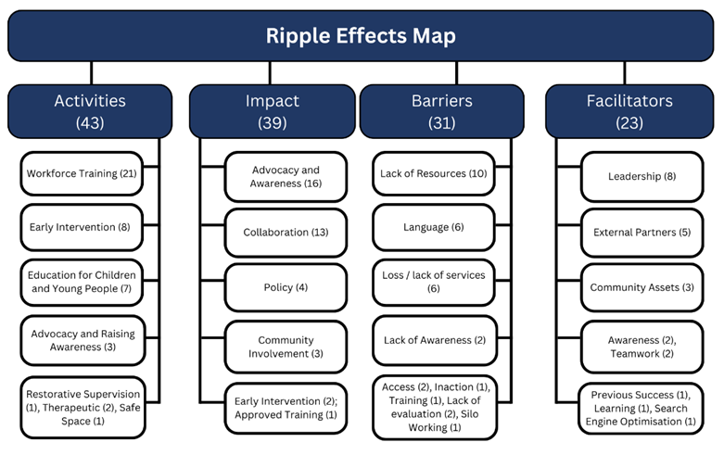

- Community Partnerships and Prevention through implementation evaluation

The 13 community partnerships across Bradford district and Craven have been the key delivery vehicle for implementing the prevention interventions for the program. The evaluation of these interventions will focus on two key areas required for the success of the program:
- The maturity of the Community Partnerships and ability to successfully use the data and supportive frameworks provided as part of the program.
- Outputs and outcomes of individual core20plus5 prevention projects and where possible groups of interventions.

Implementation evaluation focuses on assessing the process of implementing a program, project or intervention and will be used for both aspects of the prevention implementation. The intention is to understand how well a specific intervention is put in to practice as well as whether it is being delivered as intended. This will be particularly useful in identifying factors that have contributed to the success or challenges in the delivery of the initiative.

Key area 1:
All Community Partnerships are being supported in the completion of a development toolkit that will form part of the evaluation for the 6 Community partnerships that serve the Core20 population in the most deprived parts of the district. In collaboration with the Healthy Communities team the evaluation will use the outcomes of the toolkit which encourages self-assessment in three domains: Realising the power of communities; Leadership; and Partnership working.

Key area 2:
All individual core20plus5 prevention intervention projects have defined their own criteria for success from the following components:

Reach | Recruitment | Implementation
Participation | Completion | satisfaction

Every one of the prevention interventions delivered through the Core20plus5 program will have ongoing as well as a final report proportionate to the size of the project that will contribute to the overall implementation evaluation.
Several projects are being delivered at larger scale eg. Maternity circles and Community health checks allowing for greater learning and comprehensive learning on outcomes as well as outputs, these will use common reporting templates for ease of inclusion in a broader implementation evaluation.

- Clinical Priorities analysis and tracking of data.

The outcomes of the national Core20plus5 program are focussed on improving key clinical areas of health inequalities. It is anticipated that as part of the wider system focus on addressing these inequalities the Core20plus5 program will see changes to several specifically chosen clinical indicators.

To be able to track these outcomes the evaluation plan will incorporate data extracted at PCN/Community partnership level. The following table summarises the anticipated indicators to be used as part of the analysis and tracking of data. Baseline data will be taken from 2023 and final program success elicited from 2026 data.

For this part of the evaluation, we will need to consider other factors that influence the outcomes listed below. This is because core20PLUS5 funding is only a fraction locally of funding allocated to services directly addressing these outcomes. Other funding streams or initiatives particularly in Primary care (e.g., HIIP), and the wider determinants of health (e.g., poverty) will impact. This part of the evaluation will therefore provide an overview of where Bradford District and Craven is against Core20PLUS5 outcomes as a ‘system’ and where our priorities will lie (rather than as a direct result of our funded programme).

- Timeline

Overarching reporting:

Detailed activities:

