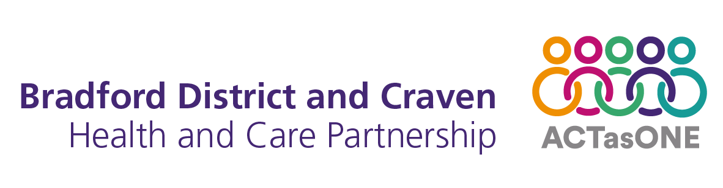

Improving physical health and reducing
premature mortality for people with severe
mental illness, learning disabilities and
autism spectrum condition

An action plan for Bradford District and Craven
2023-2026

Persons / committees consulted: | Physical Health Steering group  Community Mental Health Transformation Delivery Group  Mental Health Leadership Group
Approved by:
Date approved:
Title of lead author: | Jaspreet Sohal, Chief Pharmacist and Physical Health Service Manager at Bradford District Care NHS Foundation Trust*  Sasha Bhat, Programme Director for Healthy Minds at Bradford District and Craven Health and Care Partnership, and Deputy Director of Integration and Transformation at Bradford District Care NHS Foundation Trust  *Adapted from Improving physical health for people with serious mental illness, learning disabilities and autistic spectrum condition - a strategy for Sheffield 2019-22
Date issued: | 18/07/2023
Review date: | July 2026
Frequency of review: | 3 years
Target audience: | All staff working in community, primary and secondary care involved in the care of people with serious mental illness, learning disabilities and autistic spectrum condition.  Staff working in Bradford District and Craven Health and Care Partnership involved in commissioning services and policy setting
Responsible for dissemination: | Healthy Minds Leadership and Programme Group
Copies available from: | Healthy Minds: wellbeing@bradford.nhs.uk

Contents
2. Introduction 4
3. Developing our action plan 4
3.1 National context – severe mental illness 5
3.2 National context – learning disabilities 7
3.3 National context – autism spectrum condition 7
3.4 Bradford District and Craven context 8
4. What is our vision for Bradford District and Craven? 11
5. Our approach and delivering outcomes 16
6. Key priorities 18
7. High level action plan 19
6. References 25

Introduction
People living with severe mental illness (SMI), learning disabilities (LD) and autism spectrum condition (ASC) experience health inequalities (in most cases, avoidable) that result in premature mortality and increased morbidity compared to the general population.

Healthy Minds is our strategic and system approach to achieve better lives and brighter futures for people of all ages across our District. We established the Healthy Minds Partnership Board to bring together health and care partners across Bradford District and Craven (BD&C) to jointly oversee and propel our commitment to achieving the best outcomes for our population.

Achieving parity of esteem and improving the physical health of people with conditions such as mental illness or learning disabilities is one of our key commitments published in our Healthy Minds strategy. We know by working together, we can improve the way we support people living with these conditions to have the best possible physical health and ultimately, increase their life expectancy and the number of years lived happier and healthier.

This action plan and high-level implementation plan outlines our approach to achieve these outcomes for our communities and is for people of all ages with SMI, LD and ASC.

Developing our action plan
This action plan is presented in the context of local, regional and national drivers. Nationally there are NHS Long Term Plan (NHS LTP) ambitions to improve the physical health of people with long term conditions. At a regional level, our WY Integrated Health and Care Partnership has set two of its strategic ambitions to improve life expectancy and reduce the inequalities faced by people who have mental illness, learning disabilities and/or autism. At a local level, we have a strong commitment to ensuring we increase the life expectancy of people and ensure we increase the number of years people who live healthier for longer.

National context – severe mental illness
People with SMI often experience poor physical health as well as poor mental health.

They often develop chronic physical health conditions at a younger age than people within the general population. These chronic conditions include obesity, asthma, diabetes, chronic obstructive pulmonary disease (COPD), coronary heart disease (CHD), stroke, heart failure and liver disease.

Stigma, discrimination, isolation and exclusion are all factors that can prevent people with SMI from seeking help and accessing timely and appropriate physical health care and treatment. People with SMI can also experience diagnostic overshadowing. This is the misattribution of physical health symptoms to part of an existing mental health diagnosis, rather than a genuine physical health problem requiring treatment.

Figure 1: Interrelated dynamic elements affecting people’s mental and physical health (Public Health England 2016)

People with SMI are at increased risk of developing more than one of these chronic conditions. These physical health problems increase the risk of premature death in people with SMI.

However, SMI is rarely recorded as an underlying cause of death and indeed, is often not recorded on death certificates even as a contributory cause.

It is estimated that for people with SMI, 2 out of 3 deaths are from physical illnesses that can be prevented. Although people with SMI die prematurely from physical conditions, their SMI may still have been a significant feature in their lives, influencing both their risk of developing chronic health conditions and their access to health services.

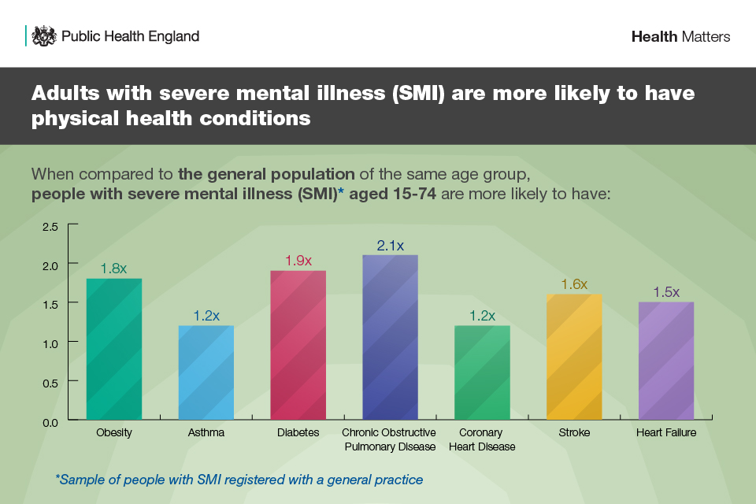
Based on data from 2016 to 2018, in England, people with SMI are 4.5 times more likely to die prematurely than those who do not have SMI. This inequality is greater for females. Females with SMI are 4.7 times more likely to die prematurely than females without SMI.
Figure 2: Health Matters (Public Health England 2018)

National context – learning disabilities
Compared with the general population, people with a learning disability were 3 to 4 times as likely to die from an avoidable medical cause of death. Most of the avoidable deaths were because timely and effective treatment was not given.
The 2021 Learning Disabilities Mortality Review (LeDeR) found the median age at death for people with learning disabilities was 62. This is significantly less than the median age of death of 83 for men and 86 for women in the general population. The leading cause of death for people with learning disabilities in 2021 was Covid19. 49% of deaths were classified as avoidable, with 17% of avoidable deaths related to diabetes and 17% related to respiratory conditions. The same report found that the most frequent long term health conditions for people were epilepsy, cardiovascular disease, mental health conditions including dementia, sensory impairments and dysphagia. LeDeR also reported the median age of death for different levels of impairment:
- 62 for people with a mild learning disability
- 63 for people with a moderate learning disability
- 57 for people with a severe learning disability
- 40 for people with profound and multiple learning disabilities.

National context – autism spectrum condition
Autism Spectrum Condition (ASC) is a lifelong condition and a part of daily life for around 600,000 people in England. It is estimated that 20-30% of people with a learning disability also have ASC. While there are no physical symptoms, an ASC diagnosis is associated with poorer health outcomes and reduced life expectancy. This is due to the multiple social disadvantages and inequalities that autistic people face in healthcare settings.
Autistic adults with a learning disability are 40 times more likely to die prematurely due to a neurological condition, with epilepsy the leading cause of death. On average, people on the autism spectrum die substantially earlier than people who are not autistic. A large study from Sweden in 2015 analysed a very large high-quality dataset which allowed for comparisons to be made between the general population, autistic people, and people with both autism and a learning disability. The study found that people with autism died over 16 years earlier than non-autistic people. Autistic adults with a learning disability were found to die more than 30 years before non-autistic people.

Bradford District and Craven context
Within BD&C there are approximately there are approximately 5034 people (all ages) on the LD case register; 3994 people living with ASC, and 6949 adults in Bradford recorded by GPs as living with SMI. There is some cross-over between the three registers, for example, people with both learning disability and autism.

Generally, the picture within BD&C correlates with the national picture in terms of excess mortality within these populations.

Figure 3 shows that within Bradford in the SMI population highest excess premature mortality is from liver disease and respiratory conditions in both males and females.

Figure 3: Excess Mortality in Bradford 2018-2020
Figure 4 shows the tendency for more people with SMI to smoke in more deprived areas which is the same trend for smoking prevalence in general population.
Smoking remains the largest single cause of preventable death in England. Whilst smoking prevalence in the general population is at an all-time low at 14.9%, amongst people with an SMI registered with a GP, it is almost three times that at 40.5% as shown by figure 5.
The contribution of factors related to socioeconomic deprivation – such as social stress and poverty is well documented as both the cause and consequence of SMI. It is recognised that individuals with SMI tend to experience a greater downward trend in socioeconomic status over time compared to the general population.

This disparity in health outcomes is partly due to physical health needs being overlooked. For too many people this means living for many years with a long-term physical health condition and with reduced quality of life.
Figure 4 Percentage of people on GP SMI registers who are smokers

Reduced life expectancy (for the majority of people) is due to a preventable illness linked to factors such as smoking, obesity, alcohol misuse and both illegal and prescribed drugs.

Poorer physical health is for the majority of people due to preventable illnesses, linked to factors such as:
- The impact of certain types of prescribed medication (for example on weight gain leading to obesity and from an increased likelihood of diabetes and cardiovascular disease), and over-prescribing of some medications (for example, antipsychotic medication for people with learning disabilities)
- Higher rates of respiratory disease linked to increased smoking rates particularly for people living with severe mental illness and due to eating and swallowing problems for people with learning disabilities.
- Lifestyle factors around physical activity, obesity, and higher rates of alcohol/illegal drug misuse for some people.
Due to the higher prevalence of significant comorbidities, people living with these conditions are also more at risk from contracting Covid19 and experiencing severe symptoms if they do contract it.
People living with these conditions are also likely to have more difficulty in monitoring their own physical health needs and in following social distancing and infection control guidance.

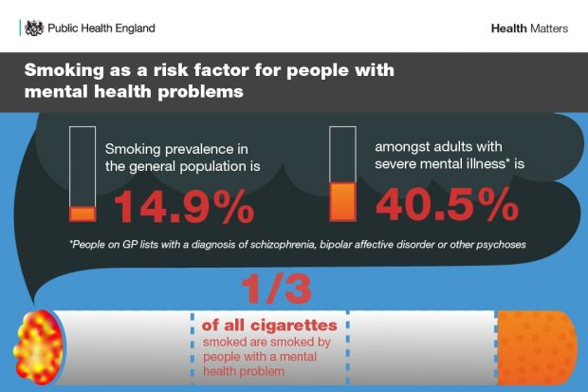

Figure 5 Smoking prevalence in the SMI population vs. general population (Public Health England 2018

What is our vision for Bradford District and Craven?
Our West Yorkshire Health and Care Partnership Integrated Care Strategy which states a series of commitments and deliverables for mental health programmes to achieve by 2025 which we will achieve through the delivery of this strategy and action plan.

More specifically, Bradford District and Craven’s vision is that:

These are three very different groups of people, but they share challenges in terms of physical health and disparity in health outcomes which are partly due to physical health needs being overlooked. For too many people this means living for many years with a long-term physical health condition and with reduced quality of life, as well as on average a dramatically reduced life expectancy.

The 5 commitments for the strategy are listed on the next page. These are underpinned by high level actions agreed by the Physical Health Steering Group to help organisations to achieve the commitments.

These will be enacted through organisations and decision-making bodies in the city identifying and embedding opportunities for improving the physical health of people living with these conditions, in their decisions, activities, strategies, and policies.

Bradford District and Craven Health and Care Partnership have also signed a pledge with Equally Well UK. Equally Well is an initiative from New Zealand which seeks to promote and support collaborative action to improve physical health among people with a mental illness.
At the heart of this strategy is ensuring that we promote better lives, respect rights and involve patients and improve support as per the Bradford District and Craven Mental Health and Wellbeing Strategy 2021-2031:
A 2023 review by The Lancet Psychiatry; Gone Too Soon: priorities for action to prevent premature mortality associated with mental illness and mental distress, identified 18 actionable solutions across three organising principles: the integration of mental and physical health care; the prioritisation of prevention while strengthening treatment; and the optimisation of intervention synergies across social–ecological levels and the intervention cycle. These are outlined in the table below and form part of the action plan outlined in section 7 and other strategies and programmes of work in BD&C Health and Care Partnership such as the Suicide Prevention Strategy, Anti-Poverty Strategy, Reducing Inequalities Alliance, Core 20+5 and Community Mental Health Transformation.
Integration of mental and physical health care | Eliminate silos in health care  Improve care-provider training and capacity-building  Access to primary care services with capacity to treat mental and physical health problems
Prioritisation of prevention while strengthening treatment | Policies to restrict access to lethal means and decriminalisation of suicide  Media and social media engagement to tackle stigma and prevent suicide  Policies targeting upstream factors to regulate tobacco and support adequate diet and nutrition  Work-based interventions to promote healthy workplaces  Early intervention, education, and public mental health awareness and training  Community-based interventions and peer engagement  Improve access to effective treatments and personalised medicine
Optimisation of intervention synergies across social– ecological levels and the intervention cycle | Strategies to reduce stigma, discrimination, marginalisation, gender violence, and victimisation  Action to reduce income inequality, such as income support and acute cash transfers  Increase investment in mental health  Redesign health systems to focus on factors that cause illness and improve treatment  Harness digital opportunities and big data  Better understanding of interplay between biomarkers and psychosocial risk factors

Bradford District and Craven’s five key commitments to people living with SMI, LD, and ASC

Our approach and delivering outcomes
The action plan will be implemented as part of our strategic priority to transform Community Mental Health services. We will establish a clear line of governance and delivery through the Healthy Minds board and its component Leadership and Oversight groups.

It is based upon national plans, research, and good practice guidance, as well as local engagement with a range of stakeholders.

One of the key commitments in the strategy is for people living with these conditions (and family/carers) to have the opportunity to influence how organisations work together to develop new and better ways of improving people’s physical health in Bradford District and Craven.

Engagement has been an important part of progressing the priority actions and refining the cross organisational strategy and the Physical Health Steering Group will continue to engage with people with lived experience, their families and stakeholder/advocacy organisations. There is also an ongoing commitment to build feedback mechanisms into improvement, commissioning, and monitoring activity.

Key components of our action plan for improving physical health for people with SMI, LD, and ASC

Key priorities

High level action plan
Commitments | Key tasks | Key measures of success | Lead
- People are proactively supported and encouraged to access the physical health care they need. | Prevent, treat or manage physical health problems, by increasing the number of people accessing annual physical health checks in SMI, LD and ASC patients.  Education for patients on how to manage and improve their physical health | Numbers of physical health checks increases in all settings  Training and awareness plan delivered (primary/secondary care, social care, VCS) with feedback mechanisms and evaluation)  121 and group education for people with SMI, LD and ASC delivered | Primary and secondary care
 | Develop and deliver with primary care shared care pathways and models to support transitions between sectors that support recovery, deliver improved physical health outcomes and embed patient reported outcome measures (PROMs) in evaluation. | Shared care pathways in place and monitored and evaluated.  PROMs embedded across services. | System partnership
 | Ensure all healthcare professionals reviewing results of annual health checks (and other ad-hoc tests/investigations) (i.e. medical staff, pharmacists, advanced clinical practitioners etc.) are aware of this strategy and health inequalities that people with SMI, LD and ASC face and understand the need to intervene early. | Increasing awareness campaigns through regular communications  Feedback from people using services. | Community mental health delivery group
 | Local screening and public health interventions i.e. vaccination services, smoking cessation services, weight loss services, cancer screening services, oral health checks, sexual health services, scanning and testing facilities are all aware of this strategy and health inequalities that people with SMI, LD and ASC face and commit to providing reasonable adjustments to accommodate their needs. Individual strategies will be needed for each of these. | VCS and BDCFT staff support people to attend appointments as needed.  Feedback from people using services. | Living Well  BDCFT  Primary Care
 | Ensure people who need support to attend appointments for screening and interventions for their physical healthcare are supported to attend where possible (this may mean accompanied attendance).  Provide lifestyle behaviour change support with brief interventions and signposting for all, including patient-led targeted goal setting.  Provide intensive behaviour change interventions where appropriate. | Implementation of reasonable adjustments. | Living well
 | Improve system wide approaches to reasonable adjustments and promoting uptake of health care support / interventions (including through innovative use of digital technology). | Implementation of reasonable adjustments. | System partnership
 | Ensure information on annual physical health checks is provided in a range of formats and languages to ensure people from different backgrounds and those with low literacy levels are not disadvantaged. | Development of leaflets/videos and availability in all settings. | Healthy Minds team
 | Establish an autistic spectrum condition register and a local approach to physical health checks. | Register is in line with NICE recommendations.  Establish process for autistic people to access annual health checks and screening and follow up interventions.
 | Strengthen tailored and targeted provision of drug and alcohol services to SMI population. | Agreed protocols in place for referral to drug and alcohol services and working | Recovery Partnership
 | Strategy to increase uptake of MECC (Making every contact count) amongst all health and care professionals in contact with people with SMI, LD and ASC. | MECC is embedded across primary and secondary care services | System Partnership  (Public health lead)
- When people are receiving health and care services to help to live with their SMI, LD or ASC they are also supported to improve their physical health | Health and Social Care planners and commissioners will require and/or support care providers to consider physical health more holistically and proactively as part of the care they provide to people with SMI, LD and ASC (for example in relation to health checks, support at appointments, or being more physically active). This will be supported by awareness raising, resources, contractual arrangements / monitoring etc as appropriate. | Changes made to existing contractual arrangements/monitoring arrangements.  Audit of contractual arrangements completed. | Commissioning team
 | Staff working in health and social care (and VCF partners where appropriate) will receive the training and awareness raising that they need to provide holistic care. | Training and awareness plan delivered (primary/secondary care, social care, VCS) with feedback mechanisms) | Healthy Minds team
 | Provide 24/7 core liaison psychiatry service at acute hospitals which support acute physical health care pathways. | 24/7 Liaison psychiatry in place | Acute crisis and liaison delivery group
 | Support the development of care pathways and protocols for frequent attendees with physical health deterioration. Offer with these a case conference management approach and ensure named clinical ownership. | Care pathways and protocols in place and used to manage frequent attendees with physical health deterioration. | Community mental health delivery group
 | Support the delivery of optimised prescribing guidelines and side effect management that utilise lifestyle interventions and strategies to support self-management, informed choice and involve family and carers. | Feedback from people using services.  Relevant, useable prescribing (and deprescribing) guidelines in place that have shared decision making principles embedded throughout | Community mental health delivery group
- People will have equal access to health living and wellbeing activities in their communities. | Determine to what extent people living with these conditions already access healthy living and wellbeing activities and support (e.g. getting more active, cutting down on alcohol, eating more healthily). | Targets based on current access / improvement required from baseline; implementation of reasonable adjustments; feedback from people using services. | Business intelligence and support team
 | Identify/implement ways to improve the accessibility of activities and support and to further promote participation, leading to more ‘open doors’/innovative ways for people to access support and advice. | Information and advice resources are updated and available. | Healthy Minds and Healthy Communities team
- People will have the opportunity to influence organisations that they use for their health and care | Produce a clear map of stakeholders and assets, which will be the basis of co-production work for activity going forward. | Clear evidence of the difference that involving people with lived experience has had in decision making and plans for improvements (case studies etc). | Healthy Minds team
 | Ensure that people with lived experience are involved in developing physical health improvement priorities and activity (including opportunities for positive peer influence and to participate in local research projects such as UCLP-Primrose).  Ensure that organisations/projects capture (and learn from) feedback and experience data | Systems in place to capture/learn from the experiences of people accessing services/support.  Evaluate the outcome of the BD4Plus ULCP-Primrose implementation pilot for consideration of system wide roll-out | Healthy Minds team  Community mental health transformation delivery group
- Key organisations & decision-making bodies in the city will ensure that they identify & embed opportunities for improving the physical health of people living with these conditions in their decisions, activities, strategies and policies | Embed physical health in key health and wellbeing strategies / action plans / initiatives and frameworks.  Partner organisations to develop their own physical health action plans that will fulfil the commitments.  Health and social care services will work more closely together closely to improve physical health outcomes for people.  There will be a cross-organisational approach to cross-cutting themes, e.g:  - Communications about the 5 commitments  - Meeting the needs of diverse communities, incl. supporting adherence to the Accessible Information Standard; and accelerating efforts to target culturally competent health promotion and disease prevention programmes.  - Increasing and developing local research opportunities  - System wide recommendations from the Physical Health Steering Group, for example regarding IT systems  - and interoperability.  - Ensuring effective medicines optimisation for people living with these conditions.  - Ensuring that larger organisations support smaller organisations to achieve the commitments.  - Identifying opportunities for employing people with lived experience | Evidence of how key strategies/action plans have incorporated the physical health commitments.  Plans in place and monitored through internal governance for:  - BD&C Health and Care Partnership  - Bradford Local Authority  - Bradford District Care NHS Foundation Trust  - Bradford Teaching Hospitals NHS Foundation Trust  - Airedale NHS Foundation Trust  - Key public health strategies  Information on physical health assessments carried out in secondary care will be routinely shared with primary care and vice versa.  Cross-organisational communications plan  developed/delivered/tested.  Local research projects delivered.  Evidence that people from BAME and other diverse communities have equitable uptake of health services (e.g. annual health checks).  STOMP and LeDeR programme delivered.  Reducing antipsychotics in dementia programme delivered | Healthy Minds Board
 | Ensuring baseline data is recurring  trends and progress monitored, with data used to improve care. | Data is collected and used to improve care efforts | CMHT delivery group
 | Identify and analyse all causes of premature death to focus physical care prevention efforts. | Data is collected and used to focus care prevention efforts | System partnership
 | Shared physical health records and treatment plans of people with SMI between primary, secondary and social care | Local standards for data sharing are in place  Clear agreements for review of physical health records between primary and secondary care  Information is evaluated and used to improve care and services. | System Partnership
 | Local data cleansing and analysis of SMI (and other) registers to establish benchmarks, gaps, unmet need and priorities. | Up to date SMI, LD and ASC registers
 | Deliver care pathways optimising local incentives to increase coverage of screening (including QoF targets) and interventions. | Appropriate local incentive schemes in place

References
Makurah, L. (2018) Health Matters: Reducing Health Inequalities in mental illness, UK Health Security Agency. Available at https://ukhsa.blog.gov.uk/2018/12/18/health-matters-reducing-health-inequalities-in-mental-illness/ (Accessed: 3 March 2023).
White, A; Sheehan, R; Ding, J; Roberts, C; Magill, N; Keagan-Bull, R; Carter, B; Ruane, M; Xiang, X; Chauhan, U; Tuffrey-Wijne, I; Strydom, A; (2022) Learning from Lives and Deaths - People with a learning disability and autistic people (LeDeR) report for 2021. rep.
Cusack, J; Shaw, S; Spiers, J; Sterry R (2016) Personal tragedies, public crisis the urgent need for a national response to early death in autism. publication. Autistica.
Nursing, Midwifery and Allied Health Professions Policy Unit, Quality Division, Strategy and External Relations Directorate 32400 (2016) Improving the physical health of people with mental health problems. Available at: https://assets.publishing.service.gov.uk/government/uploads/system/uploads/attachment_data/file/532253/JRA_Physical_Health_revised.pdf (Accessed: 3 March 2023).

O’Connor, R.C. et al. (2023) ‘Gone too soon: Priorities for action to prevent premature mortality associated with mental illness and mental distress’, The Lancet Psychiatry, 10(6), pp. 452–464. doi:10.1016/s2215-0366(23)00058-5.
West Yorkshire Integrated Care Strategy 2023 (2023) West Yorkshire Integrated Care Strategy 2023: West Yorkshire Health & Care Partnership. Available at: https://www.wypartnership.co.uk/publications/west-yorkshire-integrated-care-strategy (Accessed: 14 June 2023).

