One off personal health budgets for mental health

A leaflet for patients and their support network

Table of Contents
What are personal health budgets in mental health? 3
Who can have a personal health budget? 4
What can I use a personal health budget for? 5
Making sure personal health budgets work 7
What is a “What matters to me” conversation? 8
How do I apply for a personal health budget? 9
Personal health budget examples 10
Useful contact information 12

What are personal health budgets in mental health?
A personal health budget is NHS money to pay for a person’s health and wellbeing needs.
A personal health budget can make it easier for you to get the care and support that works for you.
You have more choice and control about how your needs are met and you can be flexible about what your support looks like.
A personal health budget is to help a person leave hospital and to be safe in the community and at home.
Personal health budgets in mental health are a system approach, which involves organisations like Bradford District Care NHS Foundation Trust, Bradford District and Craven Mind, and Bradford Council to support care and recovery of the individual in Bradford and Craven.

Who can have a personal health budget?
A personal health budget for mental health can be used by people who:
- Are currently an inpatient at Lynfield Mount Hospital, Airedale Centre for Mental Health or in an “out of area” bed but normally reside in Bradford or Craven district
- Are currently accessing support from secondary care mental health services from Bradford District Care NHS Foundation Trust, have a multi-agency care plan (three or more services involved) and at risk of being admitted or severely becoming unwell.
The personal health budget is not means tested therefore providing you are under the above services you are eligible to make an application.

What can I use a personal health budget for?
You can spend your personal health budget on things that help you meet the outcomes from your what matters to me conversation.
A personal health budget can be used to buy a service, an item or support to help you with your goals.
It could be something to help with improving your mental well-being in a therapeutic way (activities to either maintain or improve how you are feeling or the quality of your life).
We have a section later in the booklet giving some examples of what other people have found useful.
Most budgets cost up to £300.00, but we have a range of other support so please make us aware of the help you need and we will help find solutions.
There are some things you cannot use a personal health budget for. There are:
- Things which are not legal
- Gambling
- Alcohol
- Tobacco or smoking materials
- Debts (paying back money that you owe)
- Emergency health services (this would be provided by Accident and Emergency services)
- Support you get from your GP, this includes paying for certain letters as most can be provided from appropriate clinical staff, or immunisations (vaccinations)
- Medication
- Dental care services provided by primary care (high street dentists)
- Things which can already be provided by the NHS, local authority services or the voluntary and community sector unless they couldn’t provide the support without this helping.

Making sure personal health budgets work

There are some key things that the NHS need to make sure are happening so that the individual is getting a personal health budget. The person should:
- Be involved and at the centre of their what matters to me conversation and agree who is part of writing it
- Be able to agree what they want to achieve and what is important to them (staff, family or friends may help you work this out)
- Be able to meet their outcomes in a way they want to, as agreed following their what matters to me conversation.

What is a “What matters to me” conversation?

A what matters to me conversation is part of our application form for personal health budgets.

We use the conversation as a tool to help the person and staff understand what is important to the person and what works or does not work for them.

It allows staff to work with the person to find a way which will help them towards their recovery goals, finding people, services or goods which can help along the way.

The ‘what matters to me’ conversation is based around six questions, which focus on you as a person and what you feel is helpful and what is important to you. It helps staff understand you and your values.

These questions cover things such as who is important to you, what “good” and “bad” moments feel or look like for you, what others can do to help, what people like about you and how you feel a personal health budget might help and the type of help you would like.

How do I apply for a personal health budget?

If you are thinking a personal health budget might be the right support to help you, please ask for an application form from a member of staff.
After you have completed an application form, staff will send this through to an authorising team which once approved will be sent to Bradford District and Craven Mind. Bradford District and Craven Mind will then assign a practitioner who will organise to discuss the budget and any other appropriate support.
Below is an illustration of what a typical journey looks like.
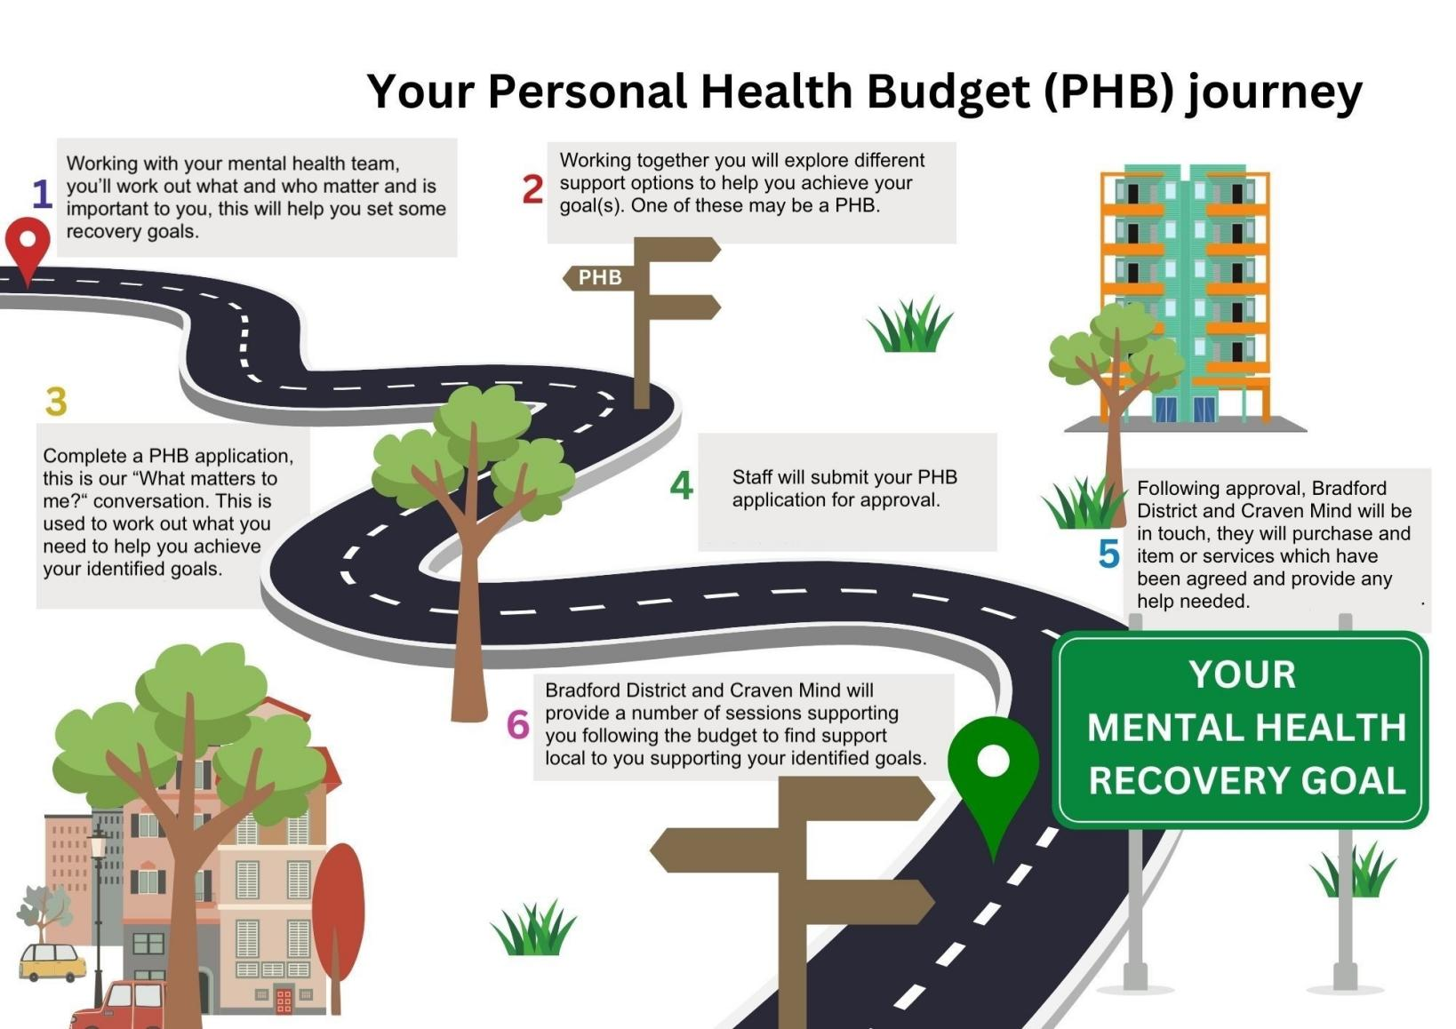Inspired by East London NHS Foundation Trust

Personal health budget examples

Below are a range of examples of things people have asked for following their what matters to me conversation.
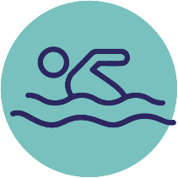
Physical activities such as bicycles, swimming classes, gym memberships, yoga classes, treadmills or sports equipment for at home. This could also include purchasing gym wear or suitable footwear.
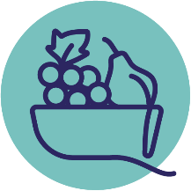
Air fryers, cooking classes or other kitchen equipment allowing you to eat healthier at home. This could include a range of white goods for example.
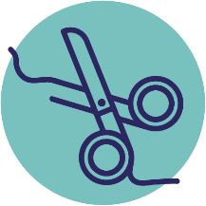
Self soothing techniques such as candles, sensory aids such as weighted blankets, manicures, pedicures, hair appointments or massages.
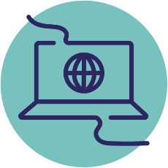
Electrical goods such as mobile phones, laptops, e-readers, netbooks, VR headsets or other technology goods.
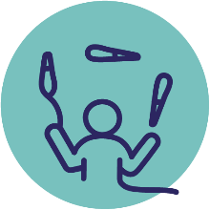
Sports TV packages, recreational goods, books, art/craft supplies, photography equipment or other hobby-based goods.

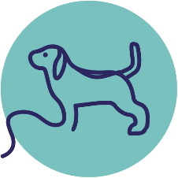
Practical support such as a dog walker, house cleans (where not covered by housing associations or local authority).
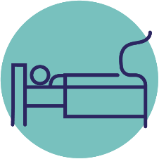
New furniture such as a bed or sofa, soft furnishings such as curtains or blinds.
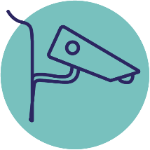
Smart doorbells or CCTV to help you feel safe at home, this could also include purchasing a dongle if you do not have Wi-Fi.
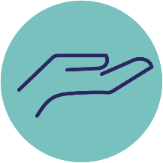
Access to culturally appropriate therapeutic support (if not available within the voluntary and community sector).
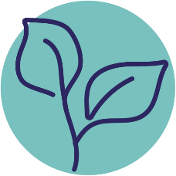
Access to supporting greener therapies such as allotments, raised beds, plants or other gardening tools.

We hope you can see that the range of support, goods or services you can ask for is varied.
The what matters to me conversation should help you explore what is important to you and can help you with your recovery journey.
It puts you in control over the help and support you would like to help you feel better.

Useful contact information
Physical wellbeing
Living well activity tracker https://livingwellbradford.activitytracker.net
Living well physical activity https://mylivingwell.co.uk/physical-activity
Living well eating well https://mylivingwell.co.uk/eating-well
Living well alcohol and drugs https://mylivingwell.co.uk/drugs-alcohol
Living well smoking https://mylivingwell.co.uk/smoking
Living well Smokefree (North Yorkshire) Phone 01609 797272 or
Email: stop.smoking@northyorks.gov.uk
New Horizons (North Yorkshire) alcohol and drugs
https://nyhorizons.org.uk
Mental wellbeing
Guideline (non-crisis mental health support) 0800 1884 884
To find mental health support and services phone guideline or visit www.healthyminds.services
First response (crisis service - requiring support within four hours) 0800 952 1181

