One off personal health budgets for mental health – application form

Once completed, please send via email to: personalhealthbudgets@bdct.nhs.uk

Patient details

Name:

Ward details: Expected Discharge Date:

Address:

Contact number:

NHS Number: Date of Birth:

Care Coordinator:

Care Coordinator contact number:

What matters to me?
Who are the most important people in your life? How often do you get to see/contact them? What do you like to do together?
We all have “good” and “bad” moments throughout the day. What does good and bad feel or look like for you?
When you are feeling low or having a “bad” day, what can others do to help you?
What do you like to do each day or each week that you would miss if you did not do, or is there something you have stopped doing and would like to start again?
What is one thing the people important to you would say they like or admire about you?
What would you like the PHB to fund? How do you see this making a difference to you? What would you like to achieve to help you with your recovery?

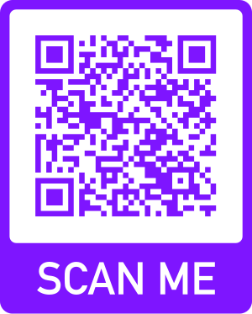
Bradford District Care NHS Foundation Trust staff
to find out more about personal health budgets
or for community signposting support, please visit
https://bdct.sharepoint.com/sites/MentalHealthPersonalHealthBudgets

