Report five: findings from interviews with staff across the Bradford District and Craven health and social care sector

Our evaluation findings are presented in five linked reports, to be read as a set or standalone.

Matthew Riley, Involvement Partner, Bradford District Care NHS Foundation Trust

Jacqui Hooley, Principal Social Worker, Bradford District Care NHS Foundation Trust
Hisham Almahayni, Senior Service Manager, Bradford District and Craven Mind
Mehnaz Akhtar, Service Manager, Bradford District and Craven Mind

Acknowledgements
We would like to thank and show our appreciation to the Bradford District and Craven Mind (formally Mind in Bradford), the Healthy Minds Partnership Board, support from regional NHS systems, the Bradford District and Craven Community Mental Health Transformation programme (community rehabilitation), City of Bradford Metropolitan District Council, national NHS services supporting alternative personal health budget (PHB) pieces of work who supported our learning and development.

Contents
Key evaluation findings 3
Introduction and scene setting 4
Our evaluation approach 1
What we did 2
What we found: 2
Promote better lives……………………………………………………………………
Respect rights………………………………………………………………………………
Improve support ………………………………………………………………………..
Impact of personal health budgets 6
Other feedback …………………………………………………………………………….
Conclusion ………………………………………………………………………………….

Key evaluation findings

Staff from across the Bradford District and Craven Health and Care Partnership
- Ongoing challenges around communication between organisations, between computer systems and patient record management systems can cause barriers in accessibility and delays in providing support at the most appropriate time.
- Partnership agreements around shared understandings of risk management and partnership working has supported allowing care being delivered differently and more conveniently to patients than previous traditional siloed working.
- Whilst barriers and difficulties have arisen during the pilot project, most incidents had considered as possible, timely resolutions have often been identified,
- Working together as a system has built improved trust and understanding across system partners.
- Working together had built and improved understanding around support those with severe mental illness, understanding around the effects of trauma and improved understandings of individuals presentations.

Introduction and scene setting
The purpose of one-off mental health personal health budgets (PHB’s) is to give people a greater degree of choice and flexibility in managing their mental health in the context of their daily life.
They offer the chance to tailor support to specific stressors, interests, or aspirations, as identified by the person themselves and can be personalised for ethnic, cultural, or religious preferences.
Personal health budgets are focussed on meeting identified health needs and can be spent on almost anything that provides an individual with appropriate care and support.
Bradford District and Craven have areas with high levels of multiple deprivation and a high prevalence of severe mental ill health.
We know from the work carried out by the Reducing Inequalities in Communities programme that if you travel 10 miles from Wharfedale to Manningham, healthy life expectancy drops by over 20 years.
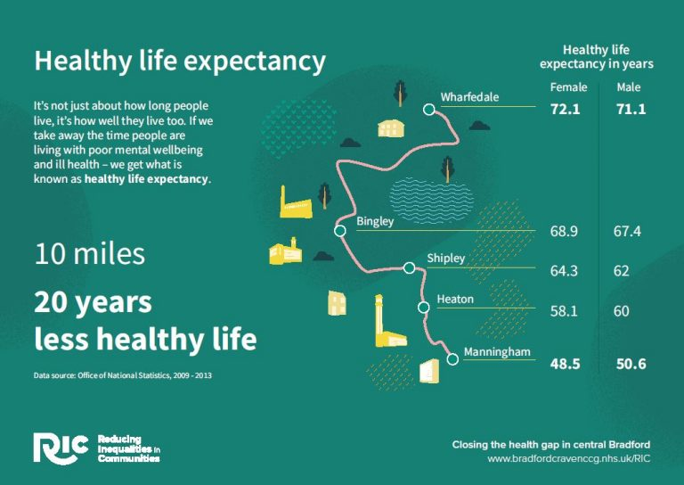
We are currently within phase one of our pilot roll out, we began with an initial focus on our inpatient wards including out of area placements and our low secure beds, as well as our Trauma Informed Personality Pathway (TIPP) service.
Data shows us that those with severe mental illness (SMI), neurodiverse or are from an ethnic minority have poorer health outcomes, these include longer stays in hospital, increased chance of reattendance to hospital, poorer access to community support and reduced access to preventative support.
We did not place restrictions on who from these populations could have access to a PHB other than being over 18 years old. Initially we had it at working age adults and not those in our older people’s service (over 65).
However, as part of the Community Mental Health Transformation (CMHT) programme we removed the upper age barrier to include older people.
We then additionally included access for those children and young people who would be accessing an inpatient bed, while as a Trust we are not commissioned to provide inpatient care to Child and Adolescent Mental Health Services (CAMHS) we had a significant pressure for inpatient beds for our children and young people, as a voice within the Bradford District and Craven Health and Care Partnership we applied a Reducing Inequalities lens and identified it would be just and equitable to include anyone who resides in Bradford District or Craven and were in an inpatient bed due to their mental health deteriorating.
We additionally recognised that we had many people accessing support across our services which was like that of our TIPP service however were not under their direct care, we therefore expanded to consider those who were under multi-agency care plans where it would aid in the prevention of admission.
Following our evaluation we have agreed to adjust our working to cover those who have a multiagency care plan (3 or more services) where it is identified the individual is at risk of deterioration and/or admission into hospital this is to reduce inequalities and provide equity of access to the communities of Bradford District and Craven.
To be eligible for a PHB there is no need to be formally sectioned or being eligible for section 117 (S117) aftercare under the Mental Health Act (MHA). Those with eligible S117 aftercare have access to more formal Personal Health Budgets since December 2019.
Additionally, we did not start off with any set funding amounts, but we did have one funding system across the patch which is being managed by our system partner Bradford District and Craven Mind.
Within the first few months we recommended a soft limit amount of £300.00 to ensure equity and sustainability within the approach, while we would allow higher ones these would be reviewed to see if a PHB was the most suitable way to support that person’s recovery journey.
Our evaluation findings are presented within this report (four other reports form the overall evaluation. These can be read as standalone or as a complete set.)
Report one: Evaluation - Key findings.
Report two: Overview summary of findings from personal health budget holders, staff and system partners highlighting key findings and learning.
Report three: Findings from interviews with patients and carers.

Report four: Findings from interviews with staff.

Report five: Findings from delivery partner and system partners.

Our evaluation approach
The primary focus was the experience of staff working across Bradford District and Craven Health and Care Partnership.
We wanted to capture feedback from our delivery partner Bradford District and Craven Mind (formally Mind in Bradford). Reflecting on new ways of system working, partnership approaches and new approaches to shared risk management and sharing information. Additionally, we wanted to reflect on the process of setting up a new service and the implementation of patient socially focused recovery interventions.
We wanted to review the experience of staff across the system who were indirectly involved in PHB’s and their understanding of the impact of the PHB.
This evaluation focuses on section five of the PHB journey (pictured below).
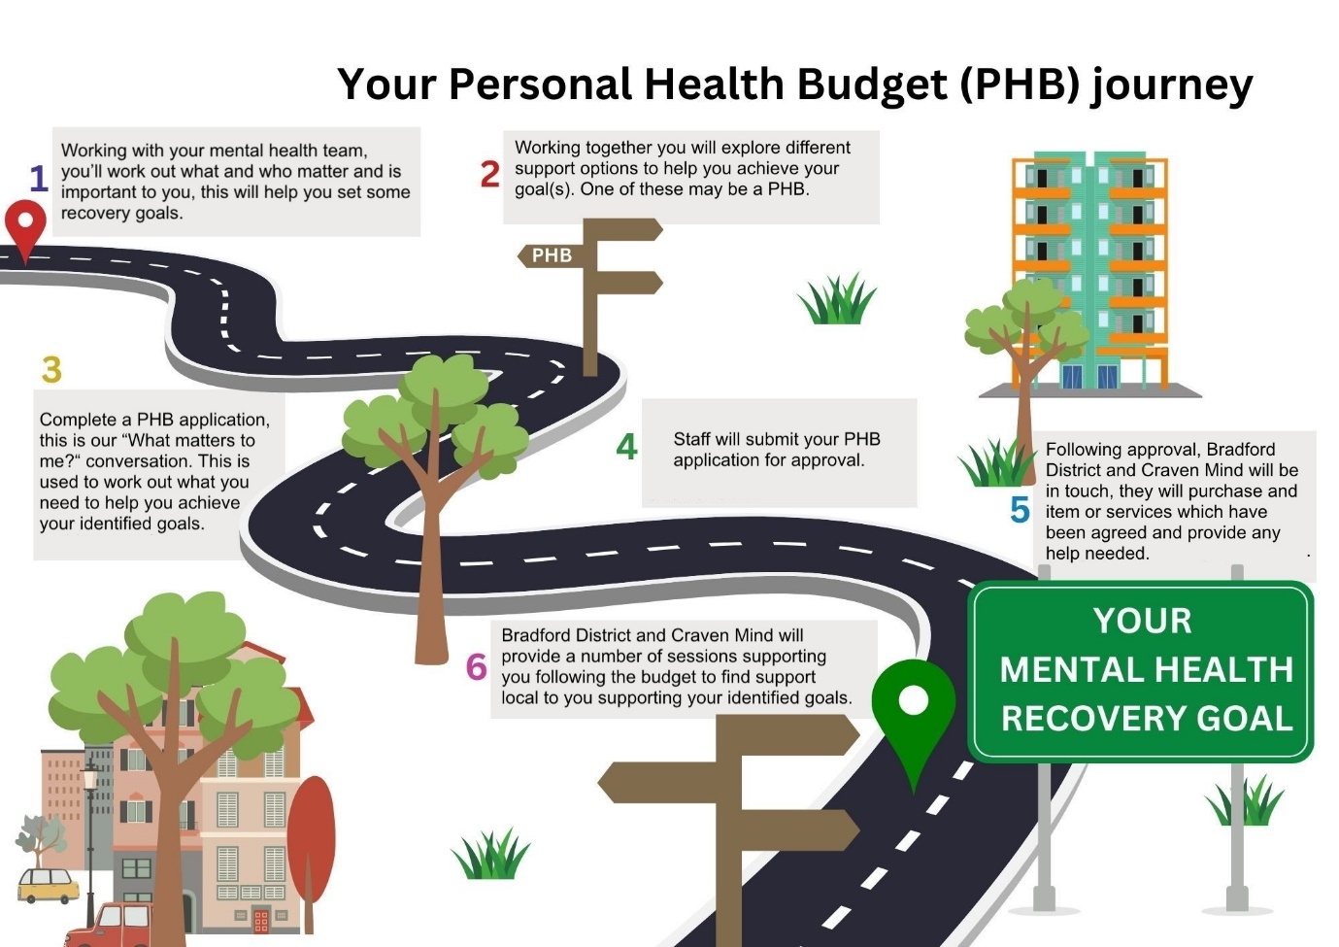
Inspired by East London NHS Foundation Trust
We invited staff from across the health and care system to reflect and provide their views on their experience and understanding of one-off personal health budgets in mental health.
We contacted our delivery partner to provide additional feedback about what had worked well and where challenges had been identified to help us review the suitability for adapting the delivery model following the pilot process.
During the pilot period we worked closely with other pieces of work within the community mental health transformation for Bradford District and Craven, we invited external organisations involved within these pieces of work to provide their reflections also.
We also collected feedback from our joint commissioner City of Bradford Metropolitan District Council, as having actively working together to ensure we provide care and support in the most appropriate way, such as through statutory provision which was then complimented by a one off PHB.

What we did

A member of staff from Bradford District Care NHS Foundation Trust and an involvement partner (person with lived experience) contacted different members of staff inviting them to have a reflection on their experiences and feedback to them.
The feedback collection was semi structured and covered their experience of being involved or affected by PHB’s and their knowledge around the pilot.

What we found
As this report focuses on our wider health and care partnership, we wanted to structure this report based around the priorities which were co-produced with those using services and staff. Healthy Minds is one of the five priorities for Bradford District and Craven Health and Care Partnership, within this priority it includes mental health, learning disabilities, neurodiversity, and substance use.

The three Healthy Minds priorities which we have based this evaluation on are:
- Promote better lives – Support everyone with the opportunities to live an independent, fulfilling, healthier and longer life.
- Respect rights – Involve people so they are informed to make choices and receive equitable access to opportunities.
- Improve support – Support people with high quality, accessible, personalised care that promotes wellbeing.
By focusing on these priorities, we ensure that our evaluation reflects on the agreed shared principles of those who access and provide services across Bradford District and Craven.
Promote better lives
One off personal health budgets for mental health initially focused on supporting working aged adults who accessed mental health services either in hospital or through the Trauma Informed Personality Pathway (TIPP) team.
Internally staff highlighted the inequity as those under older people’s inpatient care or specialist inpatient services (such as learning disabilities, low secure forensic services, inpatient rehabilitation and dementia assessment unit) were not able to access a one off PHB.
Additionally, concerns around accessibility for those under Children and Adolescent Mental Health Services (CAMHS) inpatients were also unable to access the budgets, whilst these beds are not commissioned by Bradford District Care NHS Foundation Trust, across the wider health and care partnership we support children and young people who access care through inpatient services.
Additionally, teams which provide mental health support in the community explained that their service users were not able to access support through the TIPP team but had very similar experiences and challenges.
Prior to launching our pilot staff across the system worked with people with lived experience of accessing care across Bradford District and Craven to help produce the application form and amended the wording of questions to facilitate a patient throughout their care journey, helping healthcare staff and the patient come together to understand what matters most to them, what recovery could look like and how they achieve it through a meaningful conversation and working together.
The aim to reduce fragmented care, empower patients to be included in shaping their own care and recovery journey. The “what matters to me?” conversation is aimed to support and facilitate a solution focused approach to suitable interventions to aid individualised recovery.
This approach has supported individuals, professionals and wider system partners to provide, access and deliver care and support differently for everyone. By personalising this we have supported and empowered individuals to be actively involved in designing and delivering aspects of their recovery. Our delivery partner reflected how “as a practitioner this is tremendously rewarding, and I learn new things everyday about how people with certain physical and mental challenges can be supported with such technologies.” This highlights that in addition to the identified support which has been given to the individual accessing the budget, wider benefits include the upskilling of staff knowledge across the system and helps show the value in how providing interventions and support differently in a way which engages the individual can be both therapeutic and supportive of ongoing engagement and recovery.
Our delivery partners told us how “Working with Personal Health Budget has given me the opportunity to support individuals to access items to help better aid their well-being and future. This has been reflected in the feedback with some individuals saying how receiving items will assist keeping them out of hospital.” This highlights the importance of being able to personalise care to an individual, by changing delivery to a more person-centred approach allows more creative, therapeutic interventions which are valued by the individual we provide the opportunity for them to safely explore the relationship between their mental health and their wider life, helping them explore further than a diagnosis or list of symptoms and support their wider recovery helping them at times rebuild a sense of identity.

They also commented how “Something I feel as a positive about the personal health budget is how it provides a person-centred approach to healthcare delivery. Throughout my psychology degree I researched NHS patient satisfaction and quality of life and recall research showing that NHS patients want a patient-centred approach and in recent years despite efforts by the NHS, this has been hard to deliver due to increasing pressures the NHS faces from many avenues. The personal health budget to me is brilliant answer to these issues as it involves the service users in their health decisions, while at the same time saving the NHS money, which based on my understanding is likely to increase patient satisfaction, quality of life and help the NHS economically, which will have myriads of positive side effects. As a practitioner, I see the increased satisfaction on the patients faces and this fulfils me to be a part of and I believe fulfils the service users through re-gaining some autonomy over their own healthcare.”
Respect rights
The “What matters to me?”, principles of personalised care and aims of personal health budgets aim to support involving the patient and empowering them to create a recovery pathway focused on what matters and is important to them. Our delivery partner told us how “Personally I credit Personal Health Budget on how they involve individuals in the referral and the most important factor being the individual’s personal needs and wellbeing.” By providing the space and opportunities to enable an individual to reflect on what matters to them and their values it allows us to think differently on how care and support could be accessed and what is possible for that individual.
Another reflection from our delivery partner was how “The flexibility of the way the personal health budget intervention is delivered facilitates this person centred, equitable approach to a great extent.” By working with and alongside system partners and the individual in an equal way it allows each party to look at how everyone supports removing power imbalances, by working in this way it helps improve engagement and trust between system partners and the individual.
By allowing anyone who accesses inpatient care across any of our inpatient sites or in an out of area bed, we were able to provide equity of access to anyone on our wards.
Our delivery partner told us how “We work closely in respecting each individual by tailoring appointments to how they would like to proceed for example if the individual would like to meet face to face or just talk on the telephone.” By being person centred in how individuals are contacted and supported allows support to be offered in an effective way which works for the individual, this means that support can be accessed earlier and in an appropriate way which works for both the individual but also our delivery partner.
With support from Bradford District and Craven Health and Care Partnership we created a patient and carer information booklet, posters for patients and staff to ensure that the information provided was clear, understandable and purposeful.
This allowed us to provide examples to support better understanding around potential support. We recognised some individuals struggle to identify what support may be beneficial for them or what recovery could look like.
Whilst we recognised this may be supportive for those who are neurodiverse, someone with a learning disability or those with cognitive impairment (problems with thinking, communication, understanding or memory).
We found that individuals who had Complex Emotional Needs (CEN) often struggled to identify potential support, and that the booklet supported staff to inform patients of different kinds of support, this helps support being able to make an informed choice in what their care and support could look like. Our delivery partner reflected and mentioned how “Personal Health Budget’s has helped me understand how to practically implement a person-centred approach to each case. For example, it has been a joy to be able go the extra mile to ensure our service is equitable by doings things such as more face to face contacts with specific service users who have health conditions that may make using the phone difficult or working closely with care coordinators to ensure that despite risks, we are able to provide someone with their personal health budget.”
We recognised that it was not always possible to involve the person at the time of application, this could be as the patient may have had a cognitive impairment or lacking capacity. We also had several applications for crisis admissions where items were needed right away, and the patient could not meaningfully engage as they were acutely unwell. We did however request a “what matters to me?” conversation as the patient’s mental wellbeing improved to help signpost and consider what support could help their recovery when they left hospital.
Our delivery partner highlighted how “A challenge I have faced in delivering the personal health budget service is in the pull between trying to gain feedback to help the service and signpost the service users to further support and respecting the service users wish to not be contacted. Originally I followed a 3 contact approach with every service user, collecting feedback and signposting on the third contact, however to overcome being unable to get back in contact or the service user declining further contact, I now take a more flexible approach to each case signposting and gaining feedback in the best way I can for each individual as to ensure their rights are respected and they still receive a fair service I find I must personalise how I deliver the intervention.” During our pilot we have been supporting our delivery partner in how they deliver their support and interventions, working together involving people with lived and living experience to act as experts by experience we worked together to look at alternative ways to provide support and engagement. Working together to co-produce ways which work for individuals which have not always been able to access care and support from VCSE. By working differently, we are able to tailor processes to meet the needs of the individual in a way which supports their engagement with their PHB journey and ongoing recovery.
Our delivery partner also reflected on signposting and suggestions for ongoing support, at times this could be the first experience an individual has of accessing support from a VCSE.

They advised how “One challenge I had at the beginning of working on PHB was signposting service users to further support. At first, I found there was little interest in wellbeing groups etc. However, this challenge became a positive as I discovered more beneficial ways to effectively signpost service users, such as using more open-ended questions to build some rapport and understanding of the service users and then creating more personalised approaches and recommendations to signposting.” This feedback reflects feedback we had from staff at BDCFT (Report four) and reflects on the importance of building therapeutic relationships and having conversations in psychologically safe environments. It also highlights how different organisations across they wider health and social care systems may be at different points along this journey as well as individual staff members, it highlights the strength in being able to build therapeutic relationships and therefore engage in meaningful conversations with individuals is a key part to support their recovery, but that this needs to be with everyone involved within the individuals journey regardless of role, service or organisation. The delivery partner reflected how even though “despite initially being a challenge to promote service users to engage with other resources, I found the challenge has helped me develop my relationship building skills, which has resulted in service members I work with having a greater willingness to engage in wellbeing groups and other supportive resources.”
Improve support
One off PHB’s provide flexibility on care and support options and delivery. This supports empowering patients to identify support and recovery options which are important and meaningful for them. Our delivery partner commented how “One positive aspect of working on the personal health budget which has affected me a lot has been seeing how such a range of items and services can help people in such unique ways, this has certainly developed my ability as a practitioner to really step into the shoes of our service users and improved my ability to empathise with people from all walks of life.” By involving the individual from the “what matters to me?” conversation and continually involving them throughout the PHB journey we are able to provide support in a person-centred way and what meets their identified recovery goals.
This allows more culturally appropriate options which can not always be provided by statutory services. We identified that our patient reported outcome measure ReQoL-10 did not ask about religious, spiritual or cultural beliefs and their importance to the patient, we recognised that clinical records around recording these beliefs were not always filled in and was often not documented clearly within care plans or recovery plans.
By adapting our questions within the “What matters to me?” conversation we asked people who and what are important to them, we asked if they had stopped doing an activity they used to enjoy, or qualities others admired about them. These questions often highlighted information around when their cultural, spiritual or religious beliefs were important to a patient and their recovery.
This allowed us to find appropriate support across their local community and find alternative support options from more appropriate services.
Our delivery partner told us how “I have enjoyed working in the Personal Health Budget service as we ensure they receive high quality visits where we will actively listen to their needs and quickly respond to not just the items have their requested but by signposting them to services within the Mind community.” By involving the individual in identify the support they would like to access, it creates empowerment within their own recovery, the interventions delivered by our delivery partner Bradford District and Craven Mind has complimented this process and provided additional ongoing wrap around support.
Our delivery partner also highlighted how “This brings great satisfaction that we can still offer ongoing support within our service to promote a healthy wellbeing for their future.” This has providing ongoing support to help individuals reconnect with the support available within their local community, building wider community resilience, this has also impacted on the range of individuals who have been able to access support from our delivery partner, including groups which often had not accessed support from them previously.

Signposting often included support with physical health, exercise, social groups and befriending as well as alternatives to crisis support. By identifying information gathered during the “what matters to me?” conversation it allowed our evaluation and approval team to personalise recommendations based on their own identified goals and aspirations.
The signposting process has supported wider understanding across system partners as upon approval those involved within the patient’s care is provided information around where could provide suitable support. This has helped boost staff’s knowledge of local community services, we have then been recording these on our internal SharePoint page for Bradford District Care NHS Foundation Trust staff and supporting wider system staff to be aware of support offered through the healthy minds website.
Our delivery partners highlighted how “One way the personal health budget has a massive positive impact is in improving the quality of life of service users. Through the personal health budget, we have been able to provide technology that can improve service users' ability to get into work and gain more independence.” Throughout the entire PHB process and within the initial “What matters to me?” conversation it is around letting the individual explore what and who is important to them, providing an opportunity to reflect on their past experiences, have a sense of control over their future and build a recovery pathway which is purposeful to them and their identified goals.
One of the difficulties faced by our delivery partner has been around communication between organisations, they advised how “A challenge we have faced at times on the PHB is in contacting care coordinators. Most care coordinators provide phone numbers in their email signature or occasionally on the PHB application, in which case it has been easy to contact them, and this helps the delivery of the PHB. But often it has been the case that we only have access to an email and don't get a reply on the email. In future, it would be useful to have the care coordinator number on the PHB application as most of the time we would like to have at least phone contact with each service users care coordinator, so in having the number there it would reduce barriers to delivering the service more efficiently for us.”
By adapting our processes we have began to ask for care co-ordinators details, whilst this is not always known it provides a further opportunity, we also have made suggestions on other ways to have communication between services this could be through technology, through duty workers in our community teams and building escalation processes for when contact is needed but not always available providing assurance and oversight from both the care trust and delivery partners perspective.
Another difficulty identified was around information sharing particularly around risk, mitigation and support needed, whilst all organisations have ways of managing and supporting risk, this is consistent across organisations, having shared and trusted understanding of risks has been an ongoing barrier we have worked on overcoming. Our delivery partner shared how “Additionally, we have had challenges around risk as we do not have sight on system one, this has occasionally caused some confusion. Through having the care coordinators number and some kind of consent from each service user for us discuss with the care coordinator it would also help reduce any confusions surrounding risks.” By working together as a system this allows opportunities to openly reflect on progress, positives and challenges with how information is shared and how different systems speak to each other, this is one of the key difficulties expected not only within the pilot but also within system working in a new integrated approach ot community mental health. This has allowed open discussions which not only support the individuals we support through PHB’s but help to design and support wider system conversations on new ways of working better together in future.
Additionally working alongside the local authority (City of Bradford Metropolitan District Council) we have been able to provide support in the most appropriate way, some of this has been support from the patient’s community mental health team, sometimes jointly together with a PHB complimenting each other to provide wraparound support and sometimes discussing additional support to provide ongoing care at home to prevent a person returning to hospital.

This has improved knowledge of support which can be provided by our local authority partners to support someone in the community and to support leaving hospital. It has supported our community services in understanding their policies and procedures and supported conversations around simplifying system processes to ensure patient care and safety are maintained as a priority focus for all partners involved in supporting the individual.

Impact of personal health budgets
Our pilot has been one of the key parts of work supporting the wider NHS Community Mental Health Transformation, this piece of work focus’ on improving access and support within the community for those with enduring and severe mental illness. Working together as a health, care and VCSE partnership to provide care differently, in a timely manner and seamlessly for all. Our pilot has been one of the first attempts of looking at how improved integrated working across these three different structures could be implemented, our delivery partner highlights how “Due to personal health budget involving working with such a range of NHS staff from social workers to occupational therapist to nurses, I have learned a lot about support that exists for people struggling with mental illness and due to this am able to offer this support to a wider range of people” By working collaboratively with different system partners and in a new integrated way we have been able to share information different and improve knowledge of what support is available, by working together we can ensure support is appropriate, delivered in a way that works for the individual and ensures that safety, dignity and their voice are considered and supported at each stage of the journey.

One off PHB’s have affected support access across the system differently to how we initially expected, it has allowed individuals who have not usually been able to access support from Voluntary, Community or Social Enterprises (VCSE) as part of their PHB and ongoing support. Our delivery partner reflected on their experience and shared how “A positive the personal health budget has provided to our delivery of mental health support is that through providing personalised items/services for each service member, I feel it is having a positive impact on Mind and the NHS's reputation. Multiple service users I have worked with have shown overwhelming surprise and gratitude that we have helped purchase specific items/services they have asked and when asked for feedback, some have said things like "mind is a great organisation and I hope it stays going forever as people really need this.” Empowering individuals to think differently about their care needs and care delivery allows different conversations to happen, often people with SMI have felt care is delivered to them and not with them, with a perception that their voice is infrequently and inconsistently heard, a PHB removes these perceptions by involving the individual to ensuring it is built around their own views, wants and wishes. This allows one aspect of their care to be personalised, and this allows the individual to feel empowered to reflect on their wider care and support, by working with system partners to provide care in a way which works and respects the wants and wishes of the individual.
It has allowed VCSE partners to recognise the intersectionality of severe mental illness (SMI) and other health and social conditions such as homelessness, substance use, learning disabilities and neurodiversity. Our delivery partner highlighted how “Supporting service members beyond the Personal Health Budget service by signposting to other services.” This has shown how in addition to providing the identified service or item that the ongoing personalised signposting has helped boost their support offer to individuals and provide further and additional support which has not necessarily always been available or accessed previously.

This has allowed perceived barriers and assumptions based on previous experiences to be challenged and working together with wider health and social care partners has allowed individuals to access support from wider VCSE support and services.
These experiences provide opportunities to re-traumatise and erode trust and damage therapeutic relationships between the individual and their care and support network. Our delivery partner highlighted how “A further positive in the personal health budgets ability to provide these items/services often seem to help with the service members ability to trust us as practitioners as I find that once we have helped get them their items/service they become more open to discussing their struggles with us, which can help us provide some emotional support in the moment and more effective signposting.” Similar views were recognised from BDCFT inpatient staff (more information available in report 4), recognition across Bradford District and Craven Health and Care Partnership around how working differently, involving the individual and by providing the agreed support has helped build and repair therapeutic relationships, this helps to reduce the risk of re-traumatisation and reduces the perceived barriers for individuals and their support network.
This has allowed for better engagement and ongoing support within community services and helps build further community resilience.
This has boosted engagement and empowering individuals to access support differently and earlier. This has led to improved engagement with statutory services, and a reduction in hospital readmission with 28 days.

Furthermore, this has allowed some of our anchor VCSE organisations to reflect on their current service provision and consider how they could support individuals with SMI and their wider interconnected social identities, particularly those who struggle to access or maintain engagement with statutory services. Our delivery partner shared how “As a practitioner, who works on other mental health services such as WISHH (Windhill, Idle, Saltaire, Healthy and Happy), the personal health budget has helped me learn about a wider range of services I can signpost to throughout all my work.” By working together as a system and sharing our recommended signposting and suggested support it has helped improve wider community knowledge not only internally within the trust but across our system partners and the other services provided by them, this then influences the organisations they interact with, this supports a sustainable ripple effect across the wider Bradford District and Craven Health and Care Partnership and supports better access to community support and building healthier, happier communities.
Additionally, by working along side partners within the wider community mental health transformation works and working alongside staff supporting reviewing BDCFT’s inpatient experience we have been able to create conversations around wraparound transitional care between the ward and community services and consider what other support would really benefit people accessing specialist mental health services across Bradford District and Craven, examples of this include supporting discussions on how to access support around housing repairs, supporting conversations around energy poverty (when someone reduces their energy consumption to a point where it impacts on their health and wellbeing) and energy debt. This has allowed conversations to happen across system partners so that connected and integrated work can happen reducing inefficiencies and supporting people quicker and more conveniently.

By working better together across an individual’s mental health recovery journey to their own identified goals it has supported in reducing and resisting re-traumatisation (reliving stress reactions experienced as a result of a traumatic event when faced with a new, similar situation), we have worked together to support achieving this by helping to reduce the number of times an individual needs to share their story, by focusing on an individuals strengths and building resilience and personal empowerment supporting the individual to feel seen, listened to and that services care about them, their outcome and what matters to them.
Additionally, we have provided sensory aids and soothing aids to assist individuals to manage their distress in a safe way and support them to explore and manage their own recovery, building their resilience and supporting accessing support earlier.
By doing these actions and involving the individual within their what matters to me conversation, it has helped reduce perceived power imbalances, it has helped recognise the value of an individual’s diversity and seeing the individual as a person. This has not only supported in empowering individuals within their own recovery but also helped staff across the system to recognise how care and support is delivered can cause trauma, how working differently can build and support therapeutic relationships and boost engagement and aid recovery.
Other feedback
As part of the evaluation process, we asked system partners to think about any other areas or comments around the PHB pilot, additionally we asked our delivery partner to reflect on positives of the pilot, barriers which we have identified and worked on reducing and overcoming. Below highlight some of these reflections.
Our delivery partner reflection how “It has been an honour to be a part of a great service.” They also reflected and mentioned how it is a “Great service who provides hope and a positive outlook for service members futures.” And how this has given them a “Rewarding job to be able to help promote and support service members wellbeing.”

They also spoke about the “Excellent communication with staff and BDCFT team”, but also identified how at times “It can be difficult to know which CMHT the service member is under as not always clear.” This feedback allowed BDCFT to reflect on their application process and what information was provided to the delivery partner, whilst the name of the staff member supporting the individual was shared this could change during the process, therefore following awareness of the issue the service the individual is accessing support from was shared with the delivery partner, this allows them to contact that service to provide the wrap around support as needed.
Throughout the pilot, we have been supporting individuals to leave hospital and return to care at home and in their local communities, we have been working much more closely with system partners and they have been working with individuals with different presentations to that which they had previously supported.
Whilst incidents have been rare, it highlighted how different polices and procedures and reporting between organisations affect communication and information share, our delivery partner highlighted how “knowing the process when dealing with an incident and close communications with all involved.” at times this had been a barrier which we have worked to overcome, by working together as and when incidents have been identified it has allowed trusted partnership working and understanding.
It also highlighted the importance of considerations of understanding risk assessments, lone working policies etc as although similar each organisation had different approaches and monitoring polices.

Final reflections from our delivery partner were around some of the challenges or working with inpatient and community staff and communication between all three systems. They shared how “The final challenge that was most apparent to me was some issues with delivery on one occasion where the parcel had gone missing despite being left with staff at a hospital. To overcome this challenge, if we are not able to directly deliver to the service user, we now have the staff member sign for the delivery to ensure responsibility is taken for the item.” By working together as a system we were able to think of ways of overcoming some of these challenges, this supports ensuring oversight of where items are and how support has been provided, our inpatient services are supporting people who require intensive support for their mental health recovery, focusing both on their clinical needs and wider social needs, due to this large numbers of staff from different professions and backgrounds work together to provide person centred care, however this creates opportunities for information to not always be clearly shared in a timely manner, by working together we have build ways to ensure records are updated and provide assurance that each partner has an understanding of the current progress of an individuals journey throughout their mental health recovery and PHB intervention.
Conclusion
Over our pilot period we have built stronger relationships and connections between our system partners. Working closely together and with the individual to support management of their health, care and social needs.
As joint commissioners Bradford District Care NHS Foundation Trust and City of Bradford Metropolitan District Council have forged stronger relationships and continued to work more closely together. By joint funding through one off PHB’s and provision available across wider health and social care funding we have been able to resolve identified barriers to an individual’s recovery in their own home and been able to resolve these in a timely manner and rebuild trust in statutory services with these individuals.
We have simplified processes and been able to identify areas where improvements could be made to ensure equitable access to care and support in a person-centred way.
This has supported individuals in being able to leave hospital, identify areas where services and the system can provide support and rehabilitation to improve their independence at home, with support where appropriate.
By integrating NHS healthcare and Local Authority social care more efficiently in inpatient and community mental health services we have been able to identify appropriate support and improve knowledge of staff across both organisations. This has allowed us to respond timely and in a way which the individual identifies they’ve been supported.
By working with wider VCSE partners and having Bradford District and Craven Mind as our delivery partner we have improved awareness of NHS community and inpatient staff of wider community support available, we have supported NHS staff in being able to have conversations with individuals and their support networks around what areas of their life they identify they’d like some extra support with managing, this has then allowed us to find appropriate support across the wider system.
By working with our partners we have boosted knowledge, understanding and built trust between professionals and organisations in how best to support individuals with complex or severe needs.
Our delivery partner highlighted how “Overall, the service has been great to work in which provides such a positive incentive. While there is still learning to be had for the future, I believe the whole team in the Personal Health Budget service work closely together with excellent communication and are very supportive when there are any queries or incidents.” The aims of our pilot and the health and care partnership are around promoting better lives, respecting rights and improving support. By working together in partnership during this pilot we have recognised some of the barriers of being able to implement a new way of providing care and support.

During our pilot we recognise we have been able to adapt to challenges and improve awareness of some of the key challenges we face in being able to deliver on these objectives, however the pilot has shown how when we adapt our support and care approach to a more personalised way it improves engagement, it promotes recovery, and it supports in avoiding re-traumatisation. It promotes a sense of self identity and is not only rewarding to the individual who is accessing support, but it also rewards the workforces and organisations supporting that individual and their wider support network also.
Whilst many challenges still exist, these are often at an organisational and system level such as agreements on shared records, shared risk and safety plans, contact information for services etc. Work to support these can be identified and supported at a system and management level, we also recognise that staff delivering care, supporting people in their local communities and in hospital are ready to work together and improve an individual’s experience.
Throughout our report we recognise that many improvements have been made during a short period of time and as a system we are able to adapt and think differently and creatively on how we provide care and support across Bradford and Craven District.
Whilst each organisation has its own challenges and pressures being able to provide support between organisations across the wider health and social care system to build a shared resilience and responsibility in providing support to each other has been a key strength of this process.
Our partnership has worked together, to work differently and find solutions to put the individual first and at the heart of our decision-making processes. Continuing to adapt and support people, being open and transparent around individual organisational or team challenge so as a system we can wrap around support to promote an individuals identified recovery journey.

