

Report three: findings from interviews with patients/service users who have had a personal health budget

Our evaluation findings are presented in four linked reports, to be read as a set or standalone.

Matthew Riley, Involvement Partner, Bradford District Care NHS Foundation Trust

Jacqui Hooley, Principal Social Worker, Bradford District Care NHS Foundation Trust
Hisham Almahayni, Senior Service Manager, Bradford District and Craven Mind
Mehnaz Akhtar, Service Manager, Bradford District and Craven Mind

Acknowledgements
We would like to thank and show our appreciation to the 15 individuals who participated in this evaluation, highlighting the importance of hearing the person’s voice and shaping our report and learning. We would also like to thank staff and involvement partners who assisted and supported this evaluation. Their time and input have been considerable and much appreciated, especially given capacity, workforce and workload issues.

Contents
Key evaluation findings 3
Introduction and scene setting 4
Our evaluation approach 4
What we did 9
What we found: 11
Conclusion 19

Key evaluation findings

Patients/Service Users with an approved personal health budget (PHB)
- All patients who had received a PHB who provided feedback advised how positive and inclusive the application process was, they were thankful of staff across both organisations.
- All patients who had a paired outcome measure of ReQoL-10 had at least one area which had improved or remained the same. Twenty nine out of 31 saw overall improvements in their score.
- Individuals recognised they are accessing support and care differently following their PHB, many recognised they are accessing support earlier and from wider Voluntary, Community and Social Enterprise (VCSE) organisations.
Learning points
- Patients, service users but also staff need support in rising to the challenge to thinking creatively and embracing the opportunities offered by a PHB.
- Clear communication around the nature, scope and support offered by the one off PHB is important to reduce anxiety and worry of patients considering a PHB.

Introduction and scene setting
The purpose of one-off mental health PHB’s is to give people a greater degree of choice and flexibility in managing their mental health in the context of their daily life.
They offer the chance to tailor support to specific stressors, interests or aspirations, as identified by the person themselves and can be personalised for ethnic, cultural, or religious preferences.
PHBs are focussed on meeting identified health needs and can be spent on almost anything that provides an individual with appropriate care and support.
Bradford District and Craven have areas with high levels of multiple deprivation and a high prevalence of severe mental ill health.
We know from the work carried out by the Reducing Inequalities in Communities programme that if you travel 10 miles from Wharfedale to Manningham, healthy life expectancy drops by over 20 years.
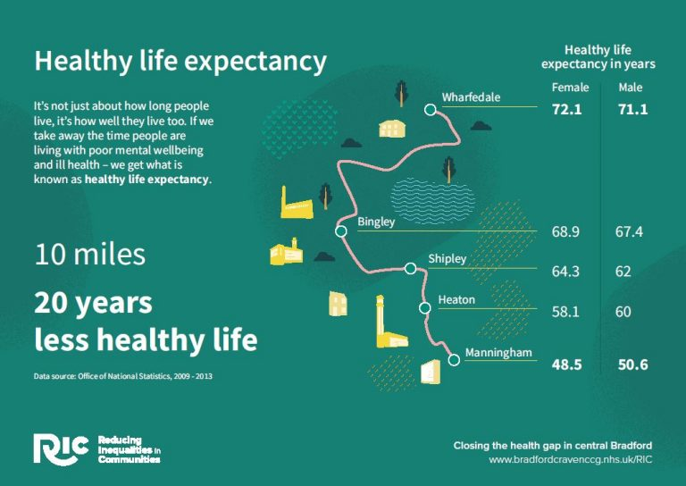
We are currently within phase one of our pilot roll out, we began with an initial focus on our inpatient wards including out of area placements and our low secure beds, as well as our Trauma Informed Personality Pathway (TIPP) service.
Data shows us that those with Severe Mental Illness (SMI), Neurodiverse or are from an ethnic minority have poorer health outcomes, these include longer stays in hospital, increased chance of reattendance to hospital, poorer access to community support and reduced access to preventative support.
We did not place restrictions on who from these populations could have access to a PHB other than being over 18 years old. Initially we had it at working age adults and not those in our older people’s service (over 65).
However, as part of the Community Mental Health Transformation (CMHT) programme we removed the upper age barrier to include older people.
We then additionally included access for those children and young people who would be accessing an inpatient bed, while as a Trust we are not commissioned to provide inpatient care to Child and Adolescent Mental Health Services (CAMHS) we had a significant pressure for inpatient beds for our children and young people, as a voice within the Bradford District and Craven Health and Care Partnership we applied a Reducing Inequalities lens and identified it would be just and equitable to include anyone who resides in Bradford District or Craven and were in an inpatient bed due to their mental health deteriorating.
We additionally recognised that we had many people accessing support across our services which was like that of our TIPP service however were not under their direct care, we therefore expanded to consider those who were under multi-agency care plans where it would aid in the prevention of admission.
Following our evaluation we have agreed to adjust our working to cover those who have a multiagency care plan (three or more services) where it is identified the individual is at risk of deterioration and/or admission into hospital this is to reduce inequalities and provide equity of access to the communities of Bradford District and Craven.
There was no need to be formally sectioned or being eligible for section 117 (S117) aftercare under the Mental Health Act (MHA), as those with eligible S117 aftercare have had access to more formal Personal Health Budgets since December 2019.
Additionally, we did not start off with any set funding amounts, but we did have one funding system across the patch which is being managed by our system partner Bradford District and Craven Mind.
Within the first few months we recommended a soft limit amount of £300.00 to ensure equity and sustainability within the approach, while we would allow higher ones these would be reviewed to see if a PHB was the most suitable way to support that person’s recovery journey.
Our evaluation findings are presented within this report (three other reports form the overall evaluation. These can be read as standalone or as a complete set).
Report one: Evaluation - Key findings.
Report two: Overview summary of findings from personal health budget holders, staff and system partners highlighting key findings and learning.
Report three: Findings from interviews with patients and carers.

Report four: Findings from interviews with staff.

Report five: Findings from delivery partner and system partners.

Our evaluation approach

The aim of our evaluation was to explore the journey and impact of our one-off personal health budgets for mental health.

Our patient journey is shown in the graphic below.
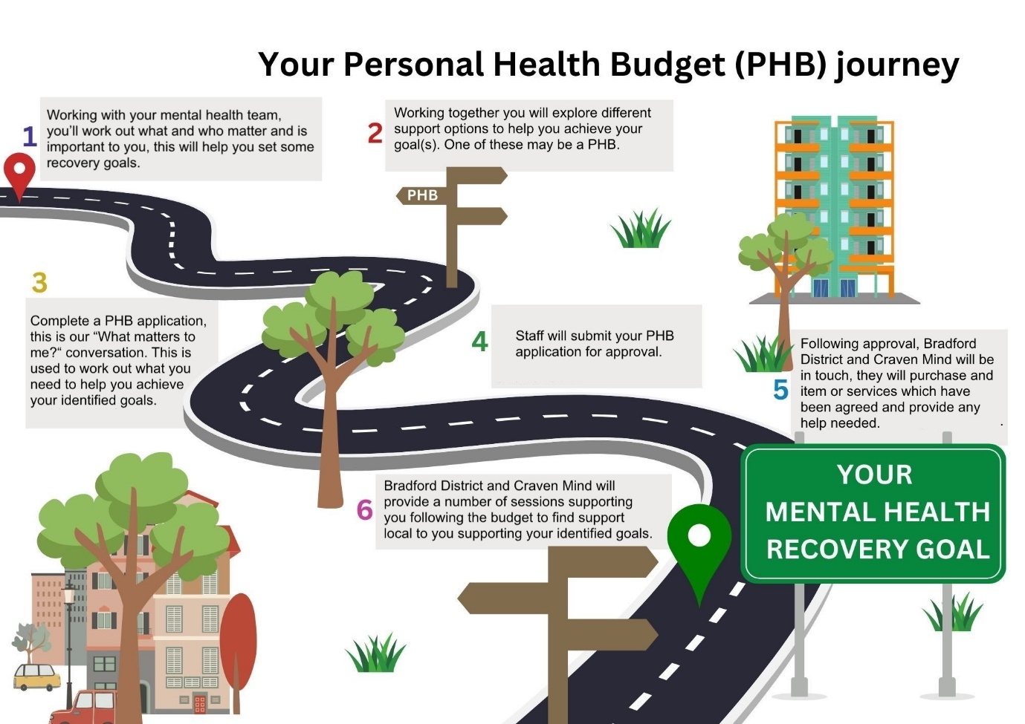
Inspired by East London NHS Foundation Trust
The primary focus was the experience of our patients and/or service users and their support networks (including unpaid carers) who had accessed a PHB.
Additionally, the experience of the workforce in implementing and delivering PHB’s was also considered important.
This report focuses on the primary focus of the experience of patients and or service users and their support networks.
Please note across Bradford District and Craven those with lived experience have suggested we use the term patient for care accessed within a hospital setting and service user for those accessing care in the community.
Our evaluation approach with patients and service users were based around their reported outcomes on the ReQoL-10 (Recovering Quality of Life 10-point scale) patient reported outcome measure as a paired outcome, one which was taken at point of application (where clinically appropriate or where the patient had consented) and a follow up as part of our evaluation and feedback capturing. Additionally, our delivery partner Bradford District and Craven Mind used a revised version of Goals Based Outcomes (GBO) to capture the experience of their clients (patients/service users) whilst they delivered the PHB’s on our behalf. We also asked several questions around the experience to those individuals who consented and agreed to provide additional feedback. Below is a list of the questions we asked.
Involvement Partners (those with lived/living experience) and Staff contacted interviews and collected feedback with people who had applied for a one-off personal health budget in mental health who had consented to being followed up.
15 individuals who had accessed a PHB provided their experience and reflections between May and September 2024.

What we did

A member of staff from Bradford District Care NHS Foundation Trust and an involvement partner (person with lived experience) contacted people who had applied for a PHB from February 2024 until July 2024 and had given consent to be contacted. This happened during May 2024 and September 2024.
The interviews/feedback collection was semi structured and covered the individuals experience and journey from applying to the completion of their budget and associated interventions.
Potential participants were contacted and asked if they would like to provide feedback. Individuals had the option or accepting or declining. Care was taken to ensure that the interview methods and associated processes were trauma sensitive, sensitive to the fluctuating nature of mental health issues and considering power dynamics and associated concerns. All documentation and processes were co-designed with people with lived experience, this person has also supported the creation of this report.
Fifteen individuals consented to provided feedback on their journey and experience of having a one off PHB in mental health. Their feedback and interview data is used within this report.
Thematic analysis of the interview data and feedback was conducted relating to the process and impact of having a personal health budget for those fifteen individuals and is presented within this report.
Additionally, we have reviewed the information provided by our delivery partner Bradford District and Craven Mind with feedback collected from their clients (patients/service users), their use of GBO which is a patient reported outcome measure.
We have also used the findings from paired outcome measures completed by those individuals and others who consented. This was by completing two ReQoL-10 outcome measures one at point of application and another following the interventions provided by our delivery partner.
The combination of the methods mentioned above provide a rich, in-depth insight into the experience of these individuals and emphasis their voice and experience.
We asked those who had accessed or applied for a one off PHB in Mental Health about their experiences and reflections, from the initial discussion, the application process, the communication, the delivery of the PHB and any signposting/ongoing support they have received. Please note we offered all of those who had consented at the time of application the opportunity to be involved and share their expeirences.
Whilst this is a small sample and may not be necessarliy representative interviewing more indivudals would likely reveal new and different issues and concerns as fifteen interviews were not sufficent for data saturation.
 | Inpatients | Community (TIPP)
Number of patients/service users invited to provide feedback | 92 | 9
Number of patients/service users who provded feedback | 14 | 1
Number of eligible patients/service users for a paired ReQoL-10 outcome | 92 | 9
Number of patients/service users with a paired ReQoL-10 outcome | 13 | 2

What we found:

What worked well?
Our sample of fifteen individuals did reflect some diversity of age, gender and ethnicity, which is comparable to those who have accessed a PHB during this period.
Please see Report 2 for demographic information on the age, gender, ethnicity of people accessing PHB’s as part of our pilot.
Everyone spent their PHB on a wide range of activities, items and services. Our approach has been focused on recovery and supporting people to leave hospital as part of a time limited pilot project. Our PHB spending tended to focus on one of items or services (please note people were able to apply for more than one item).
Whilst those eligible for S117 aftercare could have applied for ongoing support, this was not in scope of our pilot as this provision is already able to be considered within Bradford District and Craven Health and Care Partnership.
However, if we could identify sources of ongoing support to help aid an individual with their identified recovery goals, we would provide signposting and information of these services both to the referral member of staff and also our delivery partner Bradford District and Craven Mind (unless it required a clinical referral).
Spending on PHB’s fell into broad categories of home support, fitness/exercise, mobile phones, digital technology and furniture. More details about the numerous ways in which a PHB has supported people can be found in Report two.

The PHB process
All fifteen personal budget holders who we interviewed or collected feedback from for this evaluation said that PHB’s for mental health were a good idea. All participants had been positive for them. They all agreed that the focus on their life and recovery outside of hospital and non-traditional NHS community mental health support had been positive for them. All but one of those individuals who had accessed a budget whilst in hospital had felt it had helped them leave hospital earlier or more safely.
Findings about the PHB journey were grouped into five main themes:

Finding out about PHB’s
None of our fifteen participants knew about, heard or had asked for a PHB themselves.
All had been introduced to PHB’s by a health or social care professional, often an Occupational Therapist (OT).
At the time of our interviews, one off PHB’s in mental health for only a couple of months, it is a new concept to our participants as well as most professionals.
We found some inpatient staff who were unaware of PHB’s, but we also came across others such as Occupational Therapists, Purposeful Admission Co-ordinators and Mental Health Rehabilitation team were proactive.
Several participants highlighted initially being sceptical, suspicious and untrusting when the idea of a PHB was first introduced, explaining the offer in a way which supported people and gained their trust and interest was valued as important, please see the section Engaging with PHB’s below for more information.
Purpose of PHB’s
Several participants said that the professionals who had told them about the PHB’s had explained the nature and purpose well; however, they also explained that other staff were unable to answer questions or advise who could help.
Some participants referred to the patient and carer booklet and noticing the posters in the ward environment. This helped them understand what sort of things could be possible through a PHB.
Participants acknowledged the posters helped identify that the purpose was to support them in leaving hospital and accessing care and support in the community and at home. However, most participants did not feel staff made it clear that it was to support with recovery focused support and avoiding hospital re-admission.
Several participants also felt that the offer seemed too good to be true, expected it to be rejected and they felt staff explained the scope clearly to them.
Several participants identified that they felt unclear on what a PHB could be used for, when we showed them the patient/carer booklet they felt it was clearer on what a PHB could or could not support.
Some people could not identify how they would access the budget or what the next steps were, we showed them the PHB journey image, and they felt this helped simplify the overall journey.
Some participants did not feel they were able to ask for what was important to them or that it would not be allowed so asked for something else, but when asked in the feedback collection found out it would have been possible, (support with costs of going to see their daughter and dog whilst getting ready to leave hospital).
Participants did not feel the importance of having formal advocacy in helping them understand or access one off PHB’s. They did feel that support on what matters to them, the scope of items available and help received from staff when applying did make a big difference in their application process.

Some participants did feel more support around what a PHB could be used for would be beneficial. This was before we had installed posters and amended our patient/carer information booklet. When we showed these individual’s the documents, they felt it was clearer around what a PHB could be used for.
Participants did highlight that the information booklet and posters were only available in English but that staff, imagery and the language in the booklet helped them be able to understand what a PHB could be used for.
Engaging with PHB’s
Several participants described how they were uninterested, untrusting or did not believe they had been given the correct information when they first were told about PHB’s.
Participants had identified that the fear of rejection, the anxiety about planning what recovery looked like for them and a lack of consistency of staff attitude and knowledge caused them to feel anxious and therefore negatively affected about the idea of applying for a PHB.
Some participants recalled being told it had an application form and this causing re-traumatisation about their previous experiences of accessing support from other places such as Personal Independence Payments.
Participants did explain seeing other patients benefit on the ward and seeing the actual application form made them feel more confident and engaged with the application process.
Some participants identified that they struggled to imagine what was important to them and what support could be available as they were unaware of what was available and felt they needed to reply on the staff around them to support their best interests.
Several participants felt it would have been beneficial if their support network, trusted family or friends could have helped them accept a PHB earlier or support them in thinking about different ideas of what could have helped them.
Participants showed growing confidence and ownership across the PHB process as the pilot progressed, those who provided feedback later in the pilot felt staff had a clearer understanding of the process and that they had been supported into thinking about recovery and life after leaving hospital more than they had in previous admissions.

Choice and control of PHB’s
Several participants commented on the application process and the conversation they held with staff whilst applying for a PHB. Locally we have referred to our application form as a “What matters to me?” conversation.
Some participants identified staff lacked interest or sensitivity around some of the items discussed as part of the conversation particularly around things which they had previously not disclosed, that they felt ashamed of or had difficulty being open around. They felt staff moved on and did not give them the space or support they needed at the time.
Others had reacted differently and said that staff genuinely seemed interested and wanting them to be included and engaged with the process. They felt staff were engaged and making appropriate suggestions to help support them when they struggled to think of what may help them in the community.
One participant said “I was so depressed at the thought of leaving hospital I had no hot water no heating and my house was not in great shape. Molly on the ward really worked with me and you to help me get these things sorted. I don’t know what I would have done without her. Molly is a lovely person I cannot thank her enough. I was a little depressed leaving hospital but having my home in a better state made a big difference and I am doing ok.”
Several participants recognised that it was staff who had known them well and they had the opportunity to build a therapeutic relationship with who they trusted were the ones to help them apply and consider a PHB.
Participants shared that this allowed them to be open and share their fears, triggers and who could support them to make the changes they wanted to make.
Personalised and individualised conversations supported participants to feel informed and that that they had choice and control over the PHB process, but participants identified that things were missed.
Participants identified on several occasions where staff had be mindful of supporting them to think about what was important to them and making suggestions on what staff felt was important for that individual.
Some participants acknowledge that they went along with the staff suggestions whereas if they had some time to think about it or had spoken to people, they trusted they may have asked for something different or in addition to what they asked for.
However, all participants recognised that they were included in applying for their PHB and have kept the item or service they received. One participant explained they did not get everything they asked for. However following the feedback session, we were able to support and signpost on how they could access further support.
Participants had various views around the management of the budget from our delivery partner Bradford District and Craven Mind, some felt that they were unable to get the item they wanted or that they did not get a say in who was providing the item, whereas others were happy to have someone else arrange these things so that they could focus on their own recovery at a time they felt unwell.
Some participants explained they were worried about how it would affect their benefits upon leaving hospital and wanted everything to be done before they left hospital while their benefits had been paused. They seemed unaware that it was not means tested nor would it impact on any support already in place, agreed or any benefits they were receiving before, during or after their admission to hospital.
Participants explained that ward staff had given the impression they were going to be given money to purchase the items or services themselves and not that Bradford District and Craven Mind would do this on their behalf, participants said that when Bradford District and Craven Mind explained the process to them it felt clearer.
Flexibility and ongoing support
All participants highlighted that staff had made them aware of PHB’s and supported them in completing the application process.
Participants identified that having a member of staff they knew and trusted made the process easier, this particularly included Occupational Therapists particularly around home cleans as they had been to the persons home and had respected them and wanted to genuinely help them manage better in future.
Other examples were around the Purposeful Admission Coordinator who had helped them reflect on what did not work as well last time they were in hospital and how with the help of the PHB how it could be different this time.
Several participants also commented around the flexibility of the delivery partner Bradford District and Craven Mind around coming to the wards to see them, offering support over the phone and being able to send messages etc instead of having to talk to people they did not know.
Participants acknowledged that staff from health, social care and the voluntary and community sector had provided support throughout the journey whether this be staff supporting the “What matters to me?” conversation, continued support whilst in hospital, their care co-ordinator checking in with progress when leaving hospital or from ongoing support from services which had been recommended to them following their application.
Some participants highlighted difficulties contacting and receiving support from the community mental health teams but had been able to access support from third party provides such as the voluntary and community sectors both locally, nationally and virtually.
A small number of participants explained that following their what matters to me conversation the support they wanted from the PHB had changed and that staff both from the delivery partner Bradford District and Craven Mind and from the ward had been supportive in changing what was to be provided.
Some participants explained how staff on the wards had explained the process incorrectly and their expectations on how the PHB was to be provided was therefore incorrect. This caused some frustration and caused them to not want to engage or believe that they would get the items they had been promised.
Participants did acknowledge that Bradford District and Craven Mind explained the process and staff had apologised, participants recognised staff struggled to know the process in full but felt the communication was inconsistent and poor between staff and other services particularly the community mental health team.
Many participants commented on the speed and simplicity of the application and receiving the item, some identified difficulties in making contact due to not having a phone or ward staff not relaying messages in a timely manner.
Several participants found the ongoing support offered by VCSE provided significant reassurance in managing in their local communities.

The image below summaries some of the key things which worked well for patients who had accessed a PHB.

Figure 1: What worked well for those who accessed or applied for a PHB?

Impact of personal health budgets

We carried out our feedback and interviews during May to September 2024.
We offered the opportunity to feedback to applicants who had applied before 31st July 2024, it is worth noting that during July 2024 we hit a slight delay in providing PHB’s which was resolved in August 2024.
This meant that we had the opportunity to reflect and learn on different parts of the journey as we would have invited people whom had been discharged following the completion of their PHB, others who would have been in progress and others who had yet to be started.
To ensure we were as equitable as possible in our collection of feedback we offered the opportunity to all of those who had consented to being contacted by the team on their application, the only time this did not occur was where the person no longer accessed any care from the Trust anymore, where it was clinically inappropriate. As mentioned previously we wanted to ensure our process was as trauma sensitive as possible and therefore did not want to cause people to harm.
This meant we offered 100 individuals out of 110 applications to provide feedback, where adjustments were needed such as translation or where someone who the individual trusted to collect feedback were also actioned.
All participants responded advising that the budget had had a positive impact on their life and recovery and most wanted the ongoing support which had been identified to continue.
No participants reported that the budget had impacted on their life negatively.
All participants acknowledged the benefits and could see the value of the impact of the PHB on their recovery, although one participant did report that they had not received all the support they had expected to receive.
One participant said that they did not see the impact of the budget helping them to leave hospital but had found the ongoing support and signposting helpful to remain at home and in their local community. All other participants could identify how the budget either directly or indirectly aided them in feeling ready to leave hospital.
Participants acknowledged a range of different areas of their lifestyle and wellbeing which had been impacted since the start of their budget.
 | Physical health
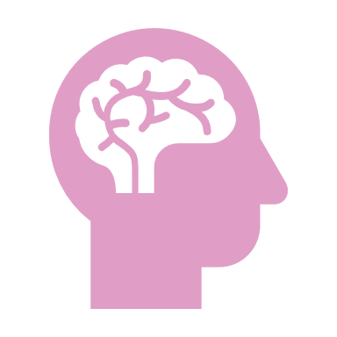 | Mental wellbeing
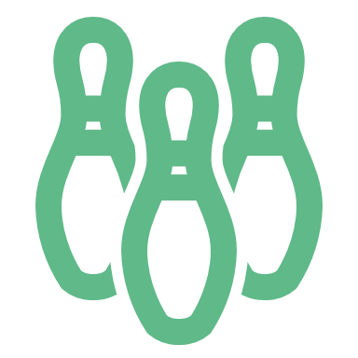 | Hobbies and interests
 | Relationships (including partners, family, friends)
 | Social Inclusion and engagement (including friends, local community and mental health services)
This information was captured based on the verbal discussions held with participants and from reflecting on the paired outcome ReQoL-10 outcome measures. More information about the areas which ReQoL-10 measures can be found in Report 2.


Improved physical and mental health and wellbeing
Most participants said their mental and physical wellbeing had improved because of their PHB. Several said before they came into hospital, they were lonely and isolated at home.
They were able to describe how going out and being more socially active had boosted their mood and activity levels.
Participants said staff from Bradford District and Craven Mind coming to see them gave them a reason to get up and out of bed. Others identified that they could now contact people they had stopped talking to and they enjoyed going out and doing social things again.
Participants identified by removing physical barriers it had helped reduce their stress and improve their overall mood. They recognised they had begun doing things again which they had previously enjoyed doing.
The one-off budgets as well as ongoing support had been attributed to supporting numerous participants regarding maintaining an improved physical and/or mental wellbeing.
Participants recognised that the reduction in overall anxiety and improved motivation demonstrated a greater value and impact than the item or service provided in the budget. Examples of this was being provided a mobile phone so they could contact people who mattered to them, but it also gave them a way to seek entertainment and support when they felt left isolated or alone.
Another participant said “I am just very grateful for all the support, and it was so nice to leave hospital to my home being tidy.“
Participants explained that by having someone support them by cleaning their home it had allowed them to begin gardening again, this had allowed them to speak to their neighbours and they now no longer felt ashamed of their property and was letting their neighbours and mental health team into the home.
Other participants explained that since leaving hospital they felt less stressed and felt hopeful around the wider community support they had been introduced to, they no longer woke up and felt like they needed a cigarette, this was saving them money but it also meant they could go out places and not cough or feel a need to be somewhere they could smoke, this had allowed them to spend more time with their children as an indirect result.
Another participant said “No I would just like to say thank you I am doing good I am back at work and hoping to go to university in September.“


Supporting interests, hobbies and activities
Participants described how their experience of the PHB and the support they had received had supported in them re-engaging or finding new hobbies or interests.
Participants recognised the importance of a strengths-based approach in identifying previous hobbies in maintaining their mental wellbeing. Participants recognised that the “What matters to me?” conversation had helped them remember and consider more creative ways of managing their distress.
One participant was able to reflect and recognise they had reduced their self-harm behaviours as they had been able to seek out alternative activities which could distract them when they struggled with their thoughts.
One participant advised how they had begun picking up new hobbies after being able to watch videos on their new mobile phone and was learning new things to do in an evening when they felt they had no one around to support them.
Several participants recognised that they had identified further things they would like to explore but could not afford or knew how to access support to engage with these. Participants recognised that if they had been given more opportunities to explore things which may have helped their recovery and re-ignite the spark in their hobbies, they may have answered the question differently from when they applied. This had been a belief from the evaluating team earlier within the project, therefore the application form had been rephrased slightly to help staff support this conversation.
Some participants explained that they felt intimidated by staff asking for things to support their hobbies as they couldn’t clearly explain how it was going to help them, one participant explained how they used to play online games with friends before going into hospital but felt unable to ask for a new game which their friends had bought while they had been in hospital.
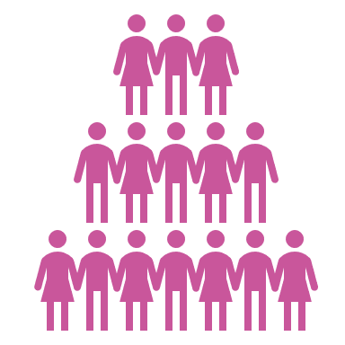
Supporting relationships and social inclusion
Most participants recognised they were more socially active and had formed new relationships with people they had met through the services they had been referred to.
One participant felt they were too socially anxious to go out and attend the groups which had been suggested to them, but they were thankful for being made aware of them and hoped to be able to attend in future.
Some participants reflected on how they were now accessing mental health support differently compared to before going in hospital, they were now accessing more group support and didn’t feel it was a mental health group as it was focused on their hobbies.
One participant said “I am doing really well and I have not been back to hospital and I am not needing to use the crisis cafe as much.”
One participant explained how the budget had supported with carrying out some repairs and decorating to their property, but this had allowed their children to feel safer and more comfortable when they visited, this gave the participant the confidence to continue works to their property and supported rebuilding the relationship they had with their children.
Participants recognised that they were not contacting their mental health team as often or needing to contact crisis services as often, they had found alternatives in their local community who could provide support in a way what worked for them. One participant said “I feel there has been a little improvement to mental health recovery I now used safe spaces through guideline who can refer me up to 3 x times a week. Safe spaces give me an hour to talk about anything I want I find this to be helpful and not problem focused.”
Participants reflected on the social support they had received from services such as Reach (peer support from The Cellar Trust), housing and benefits advisors and other support which had been signposted had helped them engage with other people again. Some participants felt like they had rebuilt trust in their NHS mental health team and had built new relationships with third party organisations from the wider health and social care system.
Reflections from the involvement partner who supported the feedback/interviews
Due to the current cost of living crisis, ongoing challenges within the NHS both from a physical health but also a mental health perspective which includes extensive waiting lists, continued cancelled appointments and news stories around several significant challenges and pressures it is very easy to avoid seeking help and not to be seen as a burden or another challenge.
Having spent over a decade accessing support in the community from the NHS and other organisations I could recognise the journeys these individuals had taken.
A focus on clinical outcomes and not a person-centred recovery creates environments and experiences where you can feel care is done to you and not with you. Where you do not think about what the future holds as it can be taken away in a moment, it never feels safe to think about tomorrow because the help to get there is not available.
The stories told by these participants reflect and bring back memories of my own care and treatment, it resonates with stories my friends tell me and their own experiences.
But hearing how their experiences and journeys changed once they had heard about PHB’s was new, the mood became more upbeat, engagement increased, it felt hopeful.
The look on someone’s face who can begin to see an alternative to their past, who feels empowered and supported to think about what they want in life and what they need to help them along that journey.
It felt like the budgets were a safety blanket to help people begin to think differently and live differently, participants had begun to build trust in services they had never considered to engage with previously.
I could see that people felt safe to explore alternatives to their previous experiences and to look at support earlier and differently.
One thing which did occur to me although the budgets themselves are a new concept all the other support that the participants had benefitted from already existed in their own communities, but they had been unaware of them.

Because care and care plans had traditionally focused on clinical outcomes and not person-centred outcomes, they had not been made aware of what support existed within their local communities or they were unaware that it was available to them (people with severe mental illness).
By having the “What matters to me?” conversation, by actively including the person, by encouraging them to think about what potentially could be possible for them it allowed the opportunity to identify other system partners across the Bradford District and Craven Health and Care Partnership who could be included and help the individual live and recover in a way that they valued.
From talking to participants, you could appreciate the level of support that they had received from the wider health and care partnership than just traditionally from the community mental health team, people could access care and support in different ways, at different times and when they needed to, individuals could find the right care and support at the right time for them.
Participants also explained how their existing mental health teams were now asking about their experiences with accessing support from different people and were more encouraging of seeking support differently.
Participants were thankful of inpatient staff in supporting them to apply for the PHB but also beneficial of the additional support which came afterwards, this includes signposting from both staff within inpatient and community services but also from system partners.
One thing I recognised from the many conversations with participants was around the levels of poverty and lack of support which had been available previously and had contributed to them needing support in hospital.
The wider interventions offered which support the budgets should hopefully build staff knowledge around community resources which can help other people under their care as I know from my own experiences that for every story I heard that someone else locally will be having similar issues and that by supporting staff and encouraging staff to think differently we can make a meaningful difference not only to those people who we have provided a PHB to but also everyone else accessing support from our community teams.
It is imperative that our Health and Care Partnership actively supports and encourages the workforce to think differently and support creative solutions to help empower, include and engage with the individual and those around them, by supporting someone to think differently about what recovery looks like for them, what support and help they need to achieve and maintain this. Without this change in culture and clear direction we are at risk of things never changing, people continuing to experience care happening to them and clinical outcomes driving care instead of person-centred recovery.
Conclusion

Empowering and supporting an individual to have choice and control over areas of their own life is significantly reduced for those people with mental health issues.

The stories told by our participants highlight how not just the budget but also the additional signposting support can improve people’s options, recovery and wellbeing.
As well as improved mental wellbeing, people reported improvements to their physical health. They talked about improvements in their level of engagement, motivation and interest in activities, more positive outlooks and improved social and family relationships.
Their stories demonstrate the value of personalised and recovery focused care, it shows the impact that small items and tailoring community support identified by the persons wants and needs is important for their wellbeing and overall recovery.
Knowing the persons background is important, having someone the person can trust to support them in thinking differently about the care they receive is important but the value and significance of improved engagement and improved resilience for that individual significantly outweigh the costs.
This review has taken place following six months of the introduction of one-off personal health budgets for mental health. Whilst this is an early stage in the project there are signs that PHB’s may have a role to play in reducing inequalities in health and social care access both as an inpatient but also in the community. PHB’s offer the opportunity to think flexibility and the freedom for bespoke support rather than the more traditional one size fits most/all.
Knowing the person is a fundamental requirement for a PHB, supporting the individual to recognise what is important to them such as religion, culture, how their gender or neurotype may be relevant to them and inform their preferences for accessing support and care.
Participants commented about how it felt to be included and involved in the process and being listened to by staff and helped by staff in exploring what and who is important to them, rather than fitting them into what care already was being provided prior to their admission.
The stories shared by our participants show how genuinely personalised conversations influence better health outcomes both in regard to physical and mental wellbeing. Their stories did highlight how things were missed by staff or peoples wishes or concerns were overlooked, more support needs to be provided to staff to help empower individuals to be actively involved and encouraged within their own recovery.
Appendix
- Questions asked to individuals who had applied for a PHB and agreed to provide further feedback. (This was available in English, Polish, Punjabi, Arabic, Urdu and Gujarati).
- Name
- Thinking back, can you remember why you wanted a personal health budget?
- Can you remember what you got from your personal health budget? If so, could you describe if possible?
- Do you still have, or did you use the item/service from the personal health budget?
- How would you describe the process of applying and getting a personal health budget?
- Did someone help you apply for the personal health budget?
- Did you feel included in applying for a personal health budget?
- Overall, could you describe your experience of applying and receiving a personal health budget?
- Did you find the support from Bradford District and Craven Mind (formally Mind in Bradford) or other services helpful?
- Do you have any other comments you would like to provide? Is there anything we could have done differently or anything looking back you would have wanted instead?
- If you would like to discuss anything related to your personal health budget, please provide us with your contact information below (This was provided on the paper/online copy of the questionnaire, however all participants completed the process with a member of the team and not alone, therefore this question was not asked)

- Patient and Carer support information booklet
- Staff and patient posters (for inpatients)
- Application form

Please note, if you are unable to open any of the documents, please contact personalhealthbudgets@bdct.nhs.uk or see supporting documents.

A copy of the questions we asked is available in the appendix
Our patient, carer and support network information booklet has been revised following feedback; a copy of our current version is included in the appendix.
We created a staff and patient poster for our inpatient areas (we amended our patient poster due to feedback. Copies of our current version are included in the appendix.
Our application form was slightly amended to be clearer for staff on what was being asked to help aid facilitation of discussions, a copy of our amended form is in the appendix.

